Manual for setting up Minecraft and
visiting the virtual EUR Campus

- Content

- Download
How to download, install and launch Minecraft on your Windows or Mac computer
- Login & Configure Version
How to log in
- Server
How to set up a connection to the server so you can visit it
- Controls
How to move around and interact with the environment when visiting the virtual campus

  - Download
How to download, install and launch Minecraft on your Windows or Mac computer
- If you already downloaded and installed Minecraft using your personal account, please go to step 2.2.
Step 1.1: Download
- Windows users go to:
https://launcher.mojang.com/download/MinecraftInstaller.msi
B) Mac users go to:
https://launcher.mojang.com/download/Minecraft.dmg
Open the downloaded Minecraft installer application; it should prompt a few questions regarding installation and should not take too much time to install (2-5 min).
Step 1.3: Launch
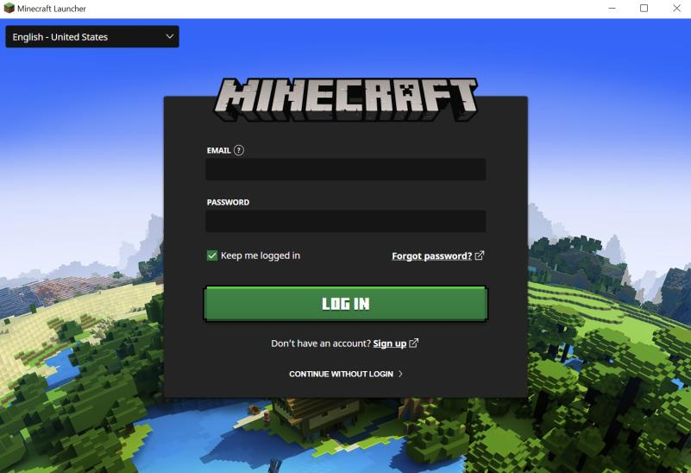
When the installer is finished, open the Minecraft Launcher. It may first need to update; this should not take long as well (2-5 min). When finished, you should be viewing this screen:

  - Login
How to log in
Step 2.1: Log in
Fill out your username and password and login to Minecraft.

Step 2.2.4: Start Minecraft Game
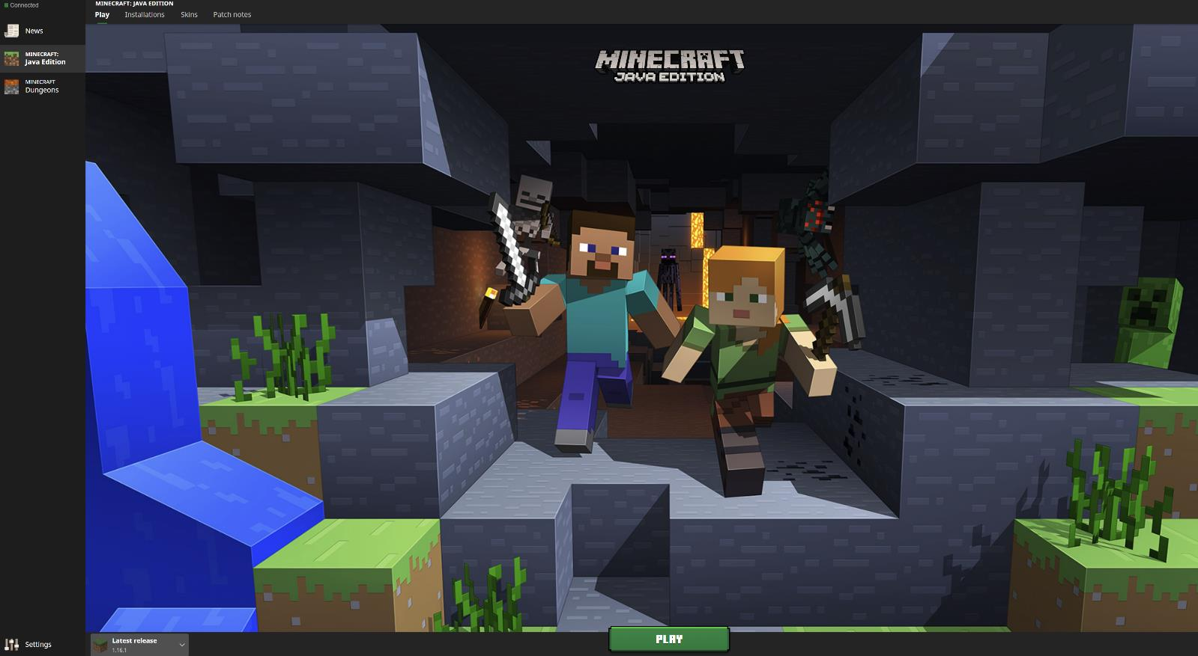
Click on the top left corner ‘Play’ and press the bottom green ‘Play’ button. This will then load you into the right Minecraft Game.

When Minecraft Game has finished loading, you will see this screen:
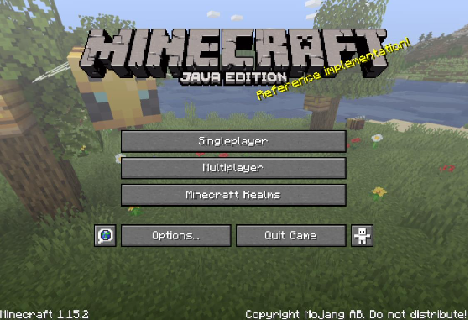

  - Server
How to set up a connection to the server so you can visit it
Step 3.1: Selecting multiplayer
Click on the “Multiplayer” button.
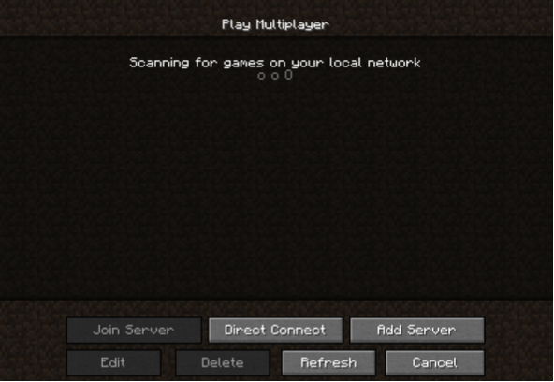
Step 3.2: Adding server
Click the bottom right saying “Add Server”; this will then you lead you the Edit Server Info Screen.

- Type “EUR Campus” In the “Server Name” section
- Type “217.182.241.98:25568” In the “Server Address” section
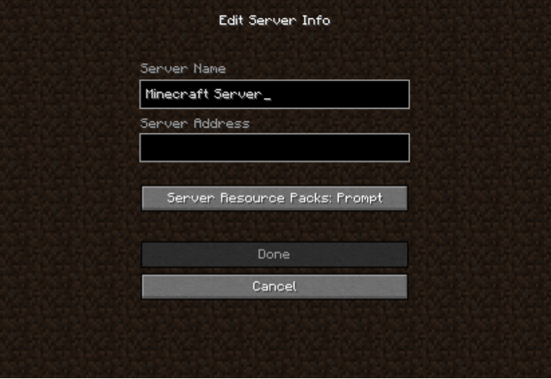
- Select ‘Done’
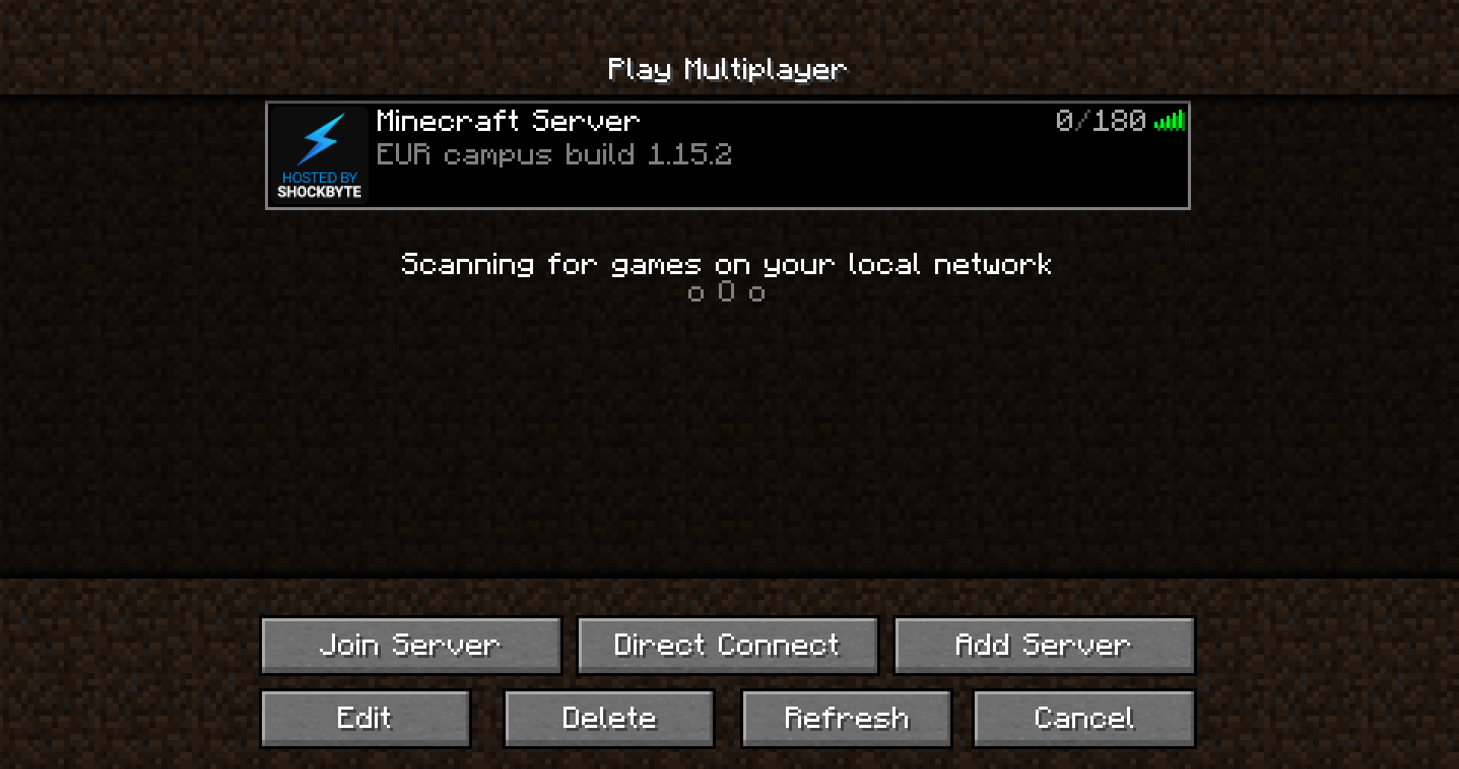
- Click on the server, then select “Join Server” at the bottom left. You will now be connecting to the server.

  - Controls
How to move around and interact with the environment when visiting the virtual campus
Step 4.1: Moving
- To move around in Minecraft, use the [W][A][S][D] keys on your keyboard.
- Looking around is done with the Mouse.
- To run, double-press one of the [W][A][S][D] keys and keep holding it; your character will move quicker
- If flying is allowed, double press the SPACE key. When flying, press SPACE to go up or press SHIFT to go down.
- To stop flying, either land on the ground or double-press SPACE again.
Step 4.2: Interacting
-By clicking the LEFT Mouse button, your character will hit whatever is in front. This can be used in different ways; you can attack another entity (if attacking someone is allowed) or break a block (if breaking it is allowed).
-By clicking the RIGHT Mouse button you can either use whatever your character is holding (e.g. a clue, or a tool such as a shield), interact with a chest and open it or place a block when you are holding one. Though this can require permission from the server to prevent anyone just building on the campus.
-Press E to open your inventory. You can rearrange items in your inventory by clicking and dragging the LEFT Mouse button. E.g. a clue from a chest to your inventory or your hand.
-Use the number 1-9 to select an item that is in your hand. By clicking the RIGHT Mouse button, you can then again interact with it e.g. read clues.

Step 4.3: Taking the metro
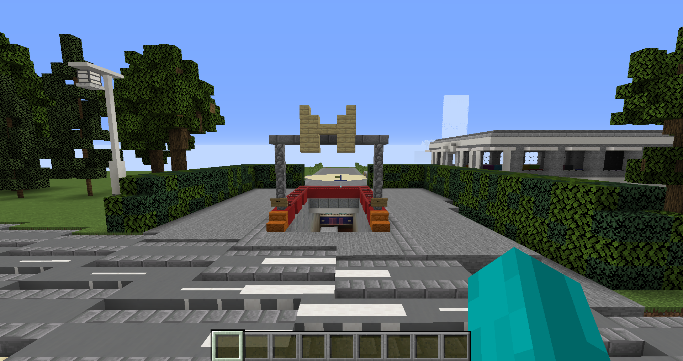
- To go to the other locations: Erasmus Medical Centre, Erasmus Centre for Entrepreneurship and Erasmus University College, find the metro station! It looks like the picture below

- Inside you will find the directions to go to the other locations. Walk through the OV Chipcard gates and you will be teleported to the metro station of that location. Walk up the stairs to continue exploring the other campuses.
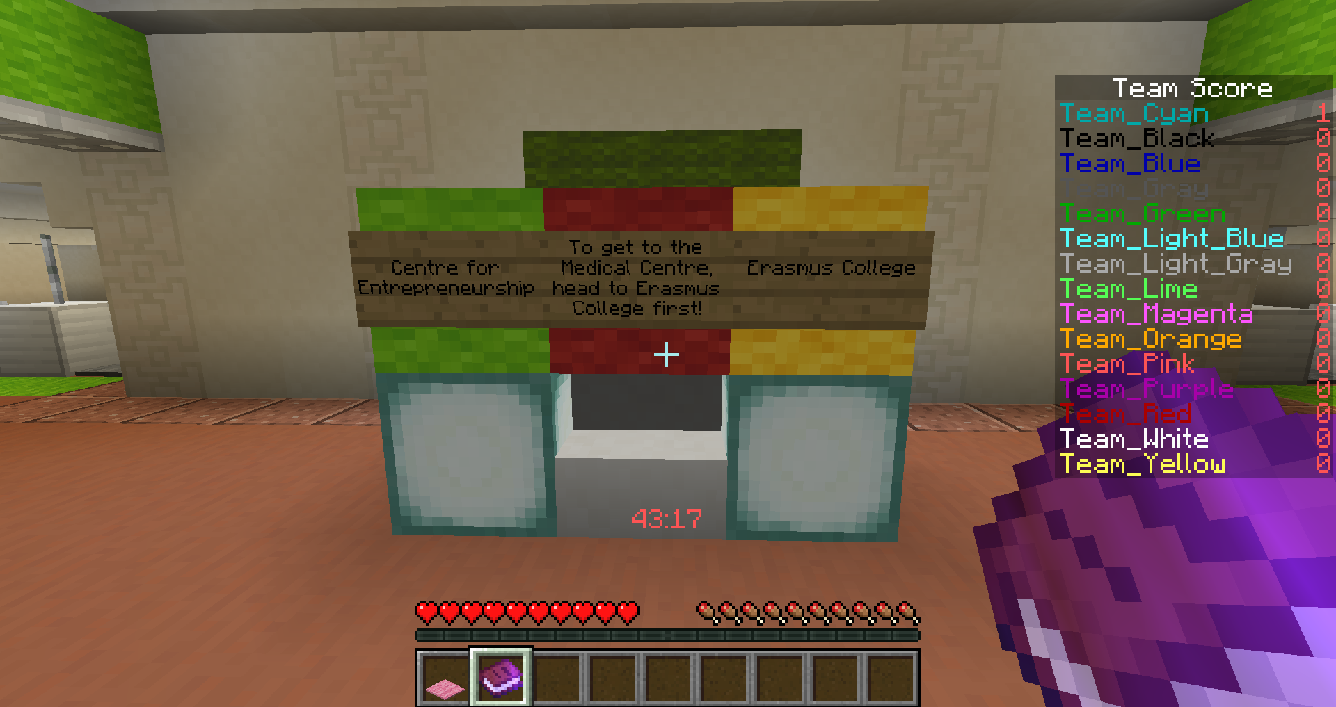

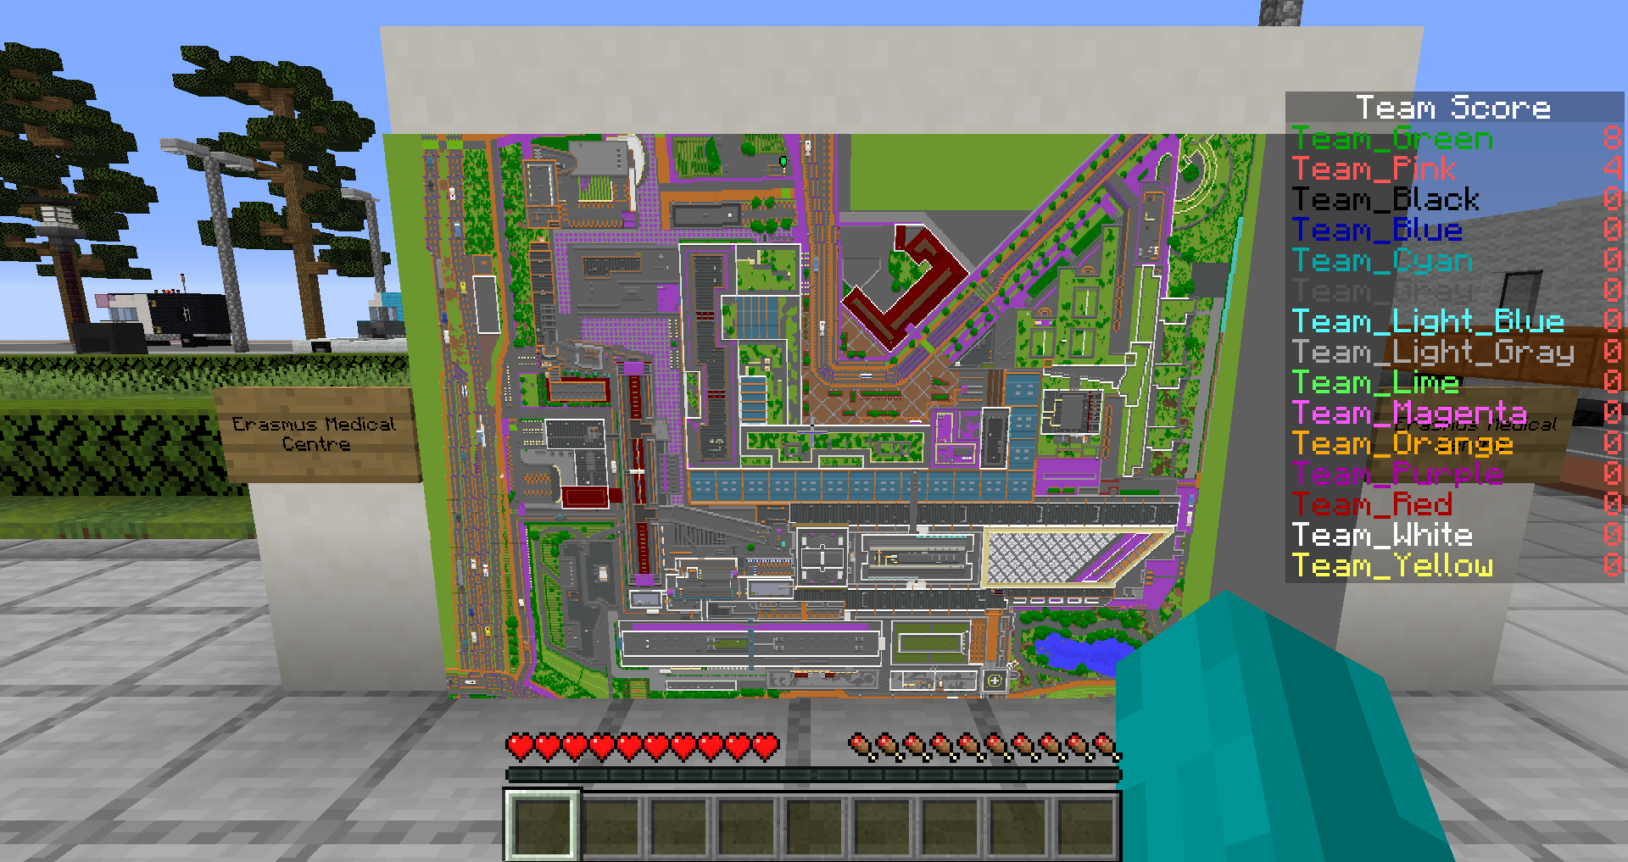
- If you get lost, you can find a map of the location next to the metro station entrance.

Step 4.3: Communicating
-In order to talk to other people in the Minecraft environment, press the [T] key to bring up the chat menu. This will allow you to type any messages you want to send to others.

Enjoy the Campus!

