

UpdaTE > June 2018
This bulletin aims to supply all employees of the department Applied Economics with relevant information. We will keep you up to date on procedures, interesting information and events. If you have any questions or comments, or if you would like to post information, please contact Manuela (ettekoven@ese.eur.nl).

Kirsten Rohde new team leader of OSE
As from 1 April 2018 Kirsten is the new team leader of OSE.

CBS room
The CBS room on the 7th floor is not available for CBS purposes anymore. For everyone who has access to CBS data the new VPN application to access the CBS microdata is available in your own application catalog.

Procedure when you are sick
When you are sick please follow the next steps:
- Let the secretariat and your supervisor know that you sick (we prefer a phone call)
- Take care of replacement and cancelling appointments
- Let the secretariat know when you are better again

The move to the E-building

Currently the move is scheduled for end November, early December. Don’t forget to tidy up your rooms in time and note the three meters per person available storage space available in the N-building.

Internships
If you supervise a student with an internship, please don’t forget to fill out the ESE Internship Assessment form and hand this to the secretariat so that they can register this for the ECTS and register in RePub. And please know that there are now standard ESE internships contracts available.
The new privacy regulations (AVG/GDPR) are here: what to expect next?
The General Data Protection Regulation (GDPR, in Dutch AVG) applies as of 25 May 2018, changing the way organisations handle and process personal data. The university is working hard to be GDPR compliant. However, it is understandable that you might wonder what these new regulations will mean to you in your daily work.
Read more

Publications in Metis
As soon as you have a publication, it is necessary to fill in Metis. This is really important because Metis is for example linked with your profile page.

From Blackboard to Canvas

Important informative: Please note that Blackboard will close and after that it is not possible anymore to access your files. If you want to keep you files please copy them to your own files.

Publications
- Iain Hamlin, Gordon R.T. Wright, Sophie van der Zee, Suart Wilson (2018): The dimensions of deception detection: Self‐reported deception cue use is underpinned by two broad factors. Applied Cognitive Psychology
- Picchio, M., S. Suetens and J.C. van Ours (2018) Labor supply effects of winning a lottery, Economic Journal, 128 (611) 1700-1729.

Profile pages
The new profile pages are online again. Please check if your page is available on www.eur.nl/en/ese/people.

Agenda
- 29 June: Department Outing, 13.30 – 20.00
- 4 October: Meeting with the Dean, 15.00 – 16.30
- 6 oktober: Bachelor Open Dag
- 20 oktober: Erasmus MC Open Dag
- 22 november: Master Open Dag

Upcoming holidays 2017
Upcoming national holidays on which the EUR is closed:
- Tuesday 25 December - Christmas
- Wednesday 26 December - Christmas Boxing Day
- Tuesday 1 January 2019 – New Year’s Day
Please note that EUR is also closed from 24 December until 31 December

New colleagues
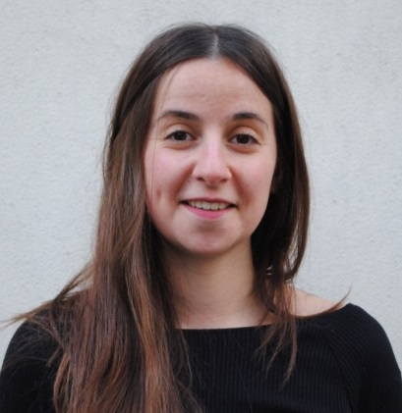 | As of 1 September 2018, we’ll welcome Marine Hainguerlot. She is a postdoc in Behavioural and Health Economics. See her homepage for more information.

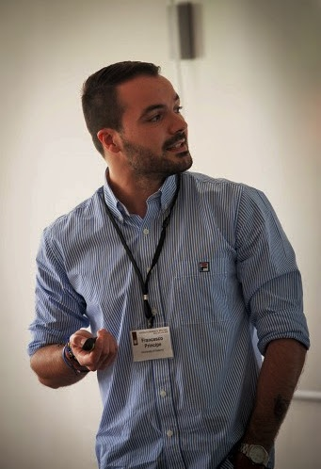 | As of 1 October 2018, we’ll welcome Francesco Principe. He is a postdoc in Applied Microeconomics. See his homepage for more information.


 | 2017 Erasmus School of Economics | disclaimer | 

