

UpdaTE >March 2019
This bulletin aims to supply all employees of the department Applied Economics with relevant information. We will keep you up to date on procedures, interesting information and events. If you have any questions or comments, or if you would like to post information, please contact Manuela (ettekoven@ese.eur.nl).

UpdaTE also on the intranet
From now on you can also find our newsletter (UpdaTE) on the website. Click here to go to the website.

Publications/interviews of our colleagues
Please let Manuela know when you have a new publication, interview or something else you want to share with your colleagues.

Marie Sklodowska-Curie Individual Fellowship for Carlos Riumallo Herl
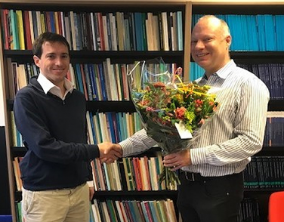 | Assistant Professor Carlos Riumallo Herl is awarded a Marie Skłodowska-Curie Individual Fellowship for his proposal ‘Disability, Labour, and Health’. This prestigious EU Horizon2020 grant to the amount of 188,000 euro is meant to encourage the mobility of researchers across national borders within the European Union. On Thursday 14 February 2019, Dean a.i. Frank van der Duijn Schouten and Dean of Research Enrico Pennings congratulated Carlos with this extraordinary achievement.  Read more

Presentation of the puzzle to Philip Hans Franses
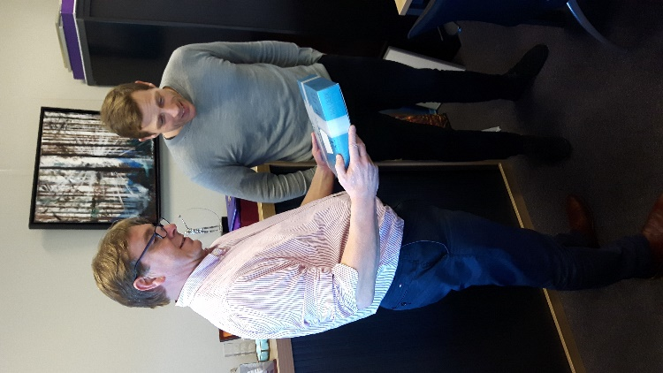 | On Friday 15 February some people of Applied Economics went to Philip Hans to give him the puzzle.  This was a gift of Applied Economics for all the years Philip Hans was our Dean.  Philip Hans was very surprised and really liked this original gift. He will let us know when he finished the puzzle.  Click here to see all the pictures.

Alumni Day on Wednesday, 3 April 2019
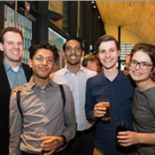 | On Wednesday, 3 April 2019, the annual Erasmus School of Economics Alumni Day will take place. The alumni day will coincide with the EFR Business Week’s annual opening congress ‘World of Business’, which will be held at Campus Woudestein. The Alumni Day starts at noon with a reception, followed by the World of Business Congress.  Read more

Working with big data / more computer power
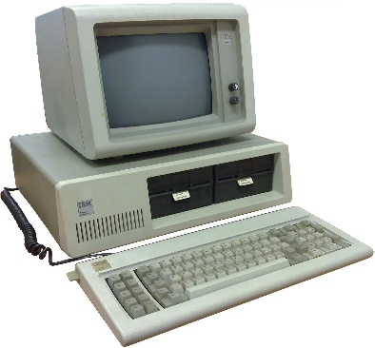 | What to do when you need to work with big data or you need access to more computer power (computing resources)?  You can get access to the computing resources by going through the following steps:
- Fill in the following form: User Request Form – Computing Resources at SURFsara.
- Read and sign the User Agreement Dutch HPC resources.
- Send the completely filled in and signed documents to edsc@eur.nl for approval.
- After EUR approval send the documents to helpdesk@surfsara.nl.
- SURFsara will send you further information on your account so that you can start with high performance computing.

Agenda
- 16 March: Bachelor Open Day
- 3 April: Alumni Day
- 11 April: ESE-bility Day
- 28 June: Department Outing

Upcoming holidays 2019
Upcoming national holidays on which the EUR is closed:
- Friday 19 April – Good Friday
- Sunday 21 April – Easter Day
- Monday 22 April – Easter Monday
- Saturday 27 April – King’s Day
- Sunday 5 May – Liberation Day
- Thursday 30 May – Ascension Day
- Sunday 9 June – Whit Sunday
- Monday 10 June – Whit Monday
- Wednesday 25 December – Christmas Day
- Thursday 26 December - Christmas Boxing Day
- Wednesday 1 January 2019 – New Year’s Day
Please note that EUR is also closed from Monday 23 December until Tuesday 31 December 2019.

New colleagues


 | 2017 Erasmus School of Economics | disclaimer | 

