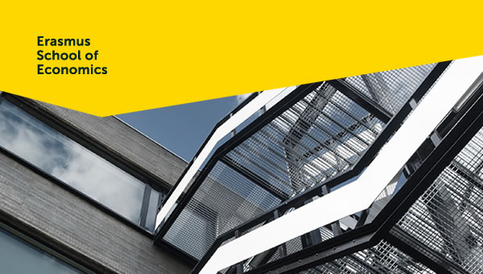

UpdaTE >July 2019
This bulletin aims to supply all employees of the department Applied Economics with relevant information. We will keep you up to date on procedures, interesting information and events. If you have any questions or comments, or if you would like to post information, please contact Manuela (ettekoven@ese.eur.nl).

UpdaTE also on the intranet
From now on you can also find our newsletter (UpdaTE) on the website. Click here to go to the website.

Publications/interviews of our colleagues
Please let Manuela know when you have a new publication, interview or something else you want to share with your colleagues.
• Bernoster, I., De Groot, K., Wieser, M. J., Thurik, R., & Franken, I. H. (2019). Birds of a feather flock together: evidence of prominent correlations within but not between self-report, behavioral, and electrophysiological measures of impulsivity. Biological psychology, 145, 112-123. https://doi.org/10.1016/j.biopsycho.2019.04.008
• De Groot, K., & Van Strien, J. W. (2019). Event‐related potentials in response to feedback following risk‐taking in the hot version of the Columbia Card Task. Psychophysiology, e13390. https://doi.org/10.1111/psyp.13390
• Van Oort, F.G. (2019), Report of the JPI Urban Europe-project “Resilient Cites”. https://urbaneurope.verdus.nl/de-economische-veerkracht-van-steden
• Phlippen, S.M.W. (20190716). Women less willing to travel far for work than men. Publication in Algemeen Dagblad. https://www.eur.nl/en/ese/news/women-less-willing-travel-far-work-men
• Peeters, T.L.P.R. (20190704). Increasing popularity of women’s football. Publication in De Morgen. https://www.eur.nl/en/ese/news/increasing-popularity-womens-football
• Phlippen, S.M.W. (20190702). Vestager stand for everything that irritates Trump. Publication in Algemeen Dagblad. https://www.eur.nl/en/ese/news/verstager-stands-everything-irritates-trump

Desktop computers in lecture rooms are switching to Office 365 ProPlus
 | This summer, all student and lecturer desktop computers in EUR lecture rooms will be equipped with Office 365 ProPlus. This means that from the coming academic year, a new version of Word, Excel, Outlook, PowerPoint, OneNote, Access, Publisher and InfoPath will be installed on these desktop computers.  Read more

Clean desk policy
 | Due to a shortage of rooms we sometimes are forced to use your office for a guest. So when you are not in your office for a few days, make sure your office has a clean desk and that all your documents are stored in closed cupboards. This is necessary because of the General Data Protection Regulation (AVG in Dutch).

Toilets N-building
 | As of next week there will be a change in man/women toilets. The changes are:  1. On the 2nd and 5th floor we will get 2 toilets for women  2. On the 1st and 4th floor we will get 2 toilets for men  3. On the 3rd floor we will get 2 gender neutral toilets  4. On the ground floor there will be no changes, this means 1 toilet for men and 1 for women

NWO Vidi Grant for Jan Stoop
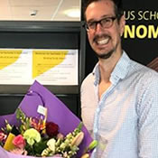 | The Netherlands Organisation for Scientific Research (NWO) has awarded Dr Jan Stoop of Erasmus School of Economics with a Vidi grant for his research “Measuring poverty with envelopes”. He will deepen the knowledge on poverty using novel field experiments requiring rich and poor households to return envelopes. The experiments mimic daily chores, and the impact of financial stress on their implementation. The results are important for future implementations of government policies

NWO Veni Grant for Chen Li
 | The Netherlands Organisation for Scientific Research (NWO) has awarded Dr Chen Li of Erasmus School of Economics with a Veni grant for her proposal “Entrapped in gender stereotypes”? The quest for gender equality appears to be more difficult than at first thought, partly because of the hidden nature of stereotyping. Li uses behavioural-economic techniques to combat stereotyping. She will be introducing a new measure of stereotyping and the welfare costs of stereotyping, will identify the causes of stereotyping and introduce new techniques to reduce stereotyping.

NWO Veni Grant for Bastian Ravesteijn
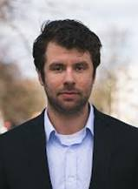 | The Netherlands Organisation for Scientific Research (NWO) has awarded Dr Bastian Ravesteijn of Erasmus School of Economics with a Veni grant for his proposal “Improving access to mental healthcare”. Some people with a psychological disorder receive insufficient care, while others receive too much care. Ravesteijn’s research used the introduction of the Personal Contribution as a natural experiment. Using statistical methods, he is researching the extent to which personal payments can result in optimum access to mental healthcare.

Carlos Riumallo Herl wins University Research Prize
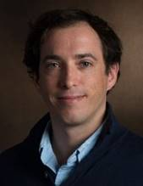 | Assistant Professor Dr Carlos Riumallo Herl has won the University Research Prize. He will receive the Prize during the festive ceremony of the Opening of the Academic Year 2019-2020, on Monday 2 September 2019.  Read more

Hans van Kippersluis appointed Professor of Applied Economics
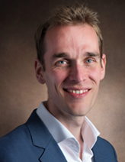 | As of 1 July 2019, Dr Hans van Kippersluis has been appointed Professor of Applied Economics, at Erasmus School of Economics. Within the broad field of applied economics, his research focuses on health behaviour and human capital.  Read more

Elbert Dijkgraaf and Emiel Maasland have won the Energy Journal Campbell Watkins Best Paper Award
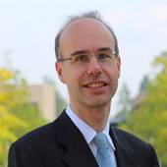 | Elbert Dijkgraaf, Professor of Empirical Economics at Erasmus School of Economics, and Emiel Maasland, Affiliated Researcher at the Department of Applied Economics at Erasmus School of Economics, have won the Energy Journal Campbell Watkins Best Paper Award for their paper on the effectiveness of feed-in tariffs in the development of solar photovoltaics.  Read more

Restructuring Education Service Centre (OSC)
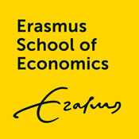 | The Executive Board of Erasmus School of Economics has decided to restructure the Education Service Centre (OSC) into three independent departments, each with their own area of expertise and manager.  Read more

Websites to calculate and buy CO2 compensation
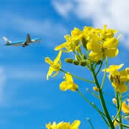 | There are several websites that can calculate your Carbon Footprint. The best ones are www.myclimate.org and for the Dutch market it’s www.greenseat.nl. These websites let you calculate your usage, but also give you a opportunity to compensate by bringing it back into balance. For example; if you fly to Bangkok and back, you use 1,6700 tons of CO2. This converted into cash is around €16,-. You can donate this amount to a good cause. This amount would provide 1 household in India, Cambodja or Uganda with renewable energy for one whole year!  For more information click here.

Reimbursements: Upload documents in one file
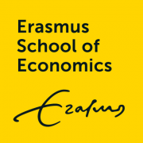 | When you are going to reimburse costs for business trips or other costs, please upload all the documents in one file.

Agenda
• 09 September: Introduction day for new employees
• 16 September: Introduction day for new employees
• 07 October: Introduction day for new employees
• 01 November: Inaugural lecture Lans Bovenberg and Paul van Geest (ESPhil)
• 11 November: Introduction day for new employees
• 10 January 2020 New Year drinks at Lokanta, 16.00 – 19.00
• 13 January 2020: Introduction day for new employees
• 16 June 2020 Department Outing 2020

Upcoming holidays 2019
Upcoming national holidays on which the EUR is closed:
- Wednesday 25 December – Christmas Day
- Thursday 26 December - Christmas Boxing Day
- Wednesday 1 January 2019 – New Year’s Day
Please note that EUR is also closed from Monday 23 December 2019 until Wednesday 1 January 2020.

New colleagues
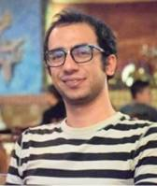 | As of 1 September 2019, we’ll welcome Vahid Moghani. He is a PhD student for the project “Family Planning, earley life and economic outcomes”.  His promotors are Tom van Ourti and Pilar Garcia Gomez.
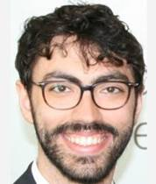 | As of 1 September 2019, we’ll welcome Francesco Capozza. He is a PhD student for the project “Field experiments on social dilemmas”.  His promotors are Aurelien Baillon en Jan Stoop.
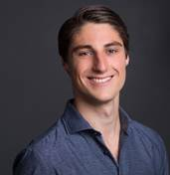 | As of 1 September 2019, we’ll welcome Markus Rösch. He is a PhD student for the project “Multinational Investment, Government Policy and the Labour Market”.  His promotors are Frank van Oort, Bas Karreman en Michiel Gerritse.


 | 2017 Erasmus School of Economics | disclaimer | 

