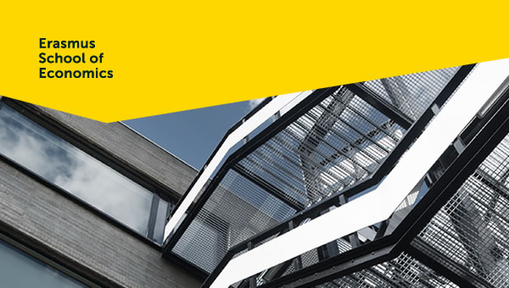

UpdaTE > October 2018
This bulletin aims to supply all employees of the department Applied Economics with relevant information. We will keep you up to date on procedures, interesting information and events. If you have any questions or comments, or if you would like to post information, please contact Manuela (ettekoven@ese.eur.nl).

Publications/interviews of our colleagues
- Sophie van der Zee:
- nominated fort the VIVA400 awards. You can vote for her until 6 November!
- interview in newspaper De Standaard, We liegen veel meer dan we denken.
- interview in Erasmus Magazine, Oplichters passen dezelfde tactieken toe als tweedehands-auto-verkopers
- interview for the BBC, How credible are lie detector tests?
Guest account has changed to Guest Wifi for EUR campus visitors

Visitors of the EUR campus can now use a special WiFi-network for guests. By texting a keyword to the phone number +316 35 777876 they will receive a login code that is valid all day. The keyword changes daily and is displayed through different channels. You can find it on the screens at the USC Front Office and in the University Library on this page.

Part of Eduroam

WiFi for guests is a welcome addition for the EUR. Up to now a special ERNA-account had to be created for guests. That is no longer the case. WiFi for guests is part of Eduroam, this new work process provides visitors temporary access to the safe Eduroam WiFi-network.

Employee survey 2018

From 29 October till 16 November every employee gets the chance to share feedback in the EUR employee survey. This survey is the last one in a series of four and will be executed by Effectory. As a supervisor it is important to voice the importance of this survey and to appeal to everyone to participate. Discuss that which you will do with the results of the survey, with your team. For more information and a concise brochure with tips and tricks, please turn to your HR business partner or advisor. Also visit MyEUR to access all of the information. Finally, as a thank you for the feedback, employees receive a free coffee/tea of your choice at the Erasmus Pavilion.

P&D cycle

A new academic year means a new P&D cycle. For some it already starts this fall. When you access the ESS portal and navigate to ‘My P&D’ you will experience the new look and feel of the homepage. It’s even easier to navigate to your form, FAQ’s and your personal settings. There is a direct button on the homepage to change your (language) settings. On top of that the mobile app SuccessFactors is available for Android and Apple. Go to ‘Settings’ and you will see on the left menu the ‘Mobile’ button to follow the instructions. Lastly, you can sign up for the P&D conversation training for supervisors on the TOP website.

ESE Prep Money Research
Erasmus School of Economics (ESE) encourages its faculty to apply for prestigious external research funding at NWO, the European Commission (ERC and Marie Curie ITN) or other established research funding organizations.
ESE has created a specific instrument to help researchers to get the time and opportunities required for the solid preparation of a strong research proposal: Prep Money Research. This allowance can only be used (and applied for) before the submission of the grant application and your head of department needs to approve how you intend to spend the money.
For more information click here.

Employment Conditions Selection Model (ECSM) (KMA forms)

The Employment Conditions Selection Model (ECSM) processes, such as using leave days (max 80 hours) and commuting travel expenses will be replaced by digital employee self-service (ESS) scenarios in October. One of the changes in this process is that the approval of managers is no longer necessary now that this is an employee right agreed in the CLA for Dutch Universities (NU). Starting from around the end of October, instead of using the current paper forms, employees can also submit these requests via the ESS Portal.

Copy or download your content from blackboard *High importance*
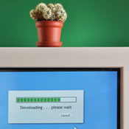 | As the Blackboard license expires on 1 January 2019, it is of utmost importance to download all you files from Blackboard before this date.  If you do not do this, all your content will be lost, since Blackboard will not be available after 31 December 2018.
When you want to save or re-use content which is currently stored on Blackboard, you have to copy this content yourself (or ask one of your SA’s to do it) and store it either in Canvas or on your personal desktop. On the ESE Canvas website you can download an instruction on how to upload the content in your Canvas course.
All 2018-2019 courses are available on Canvas. You can find your course on canvas.eur.nl. Log in with your ERNA-id.

Agenda
- 22 November: Master Open Day
- 23 November: Inauguration Frank van Oort, 16.00 – 17.00 in the Aula
- 10 January: New Year drinks, Proeflokaal Lokanta, 16.00 – 19.00

Upcoming holidays 2018
Upcoming national holidays on which the EUR is closed:
- Tuesday 25 December - Christmas
- Wednesday 26 December - Christmas Boxing Day
- Tuesday 1 January 2019 – New Year’s Day
Please note that EUR is also closed from 24 December until 31 December

New colleagues


 | 2017 Erasmus School of Economics | disclaimer | 