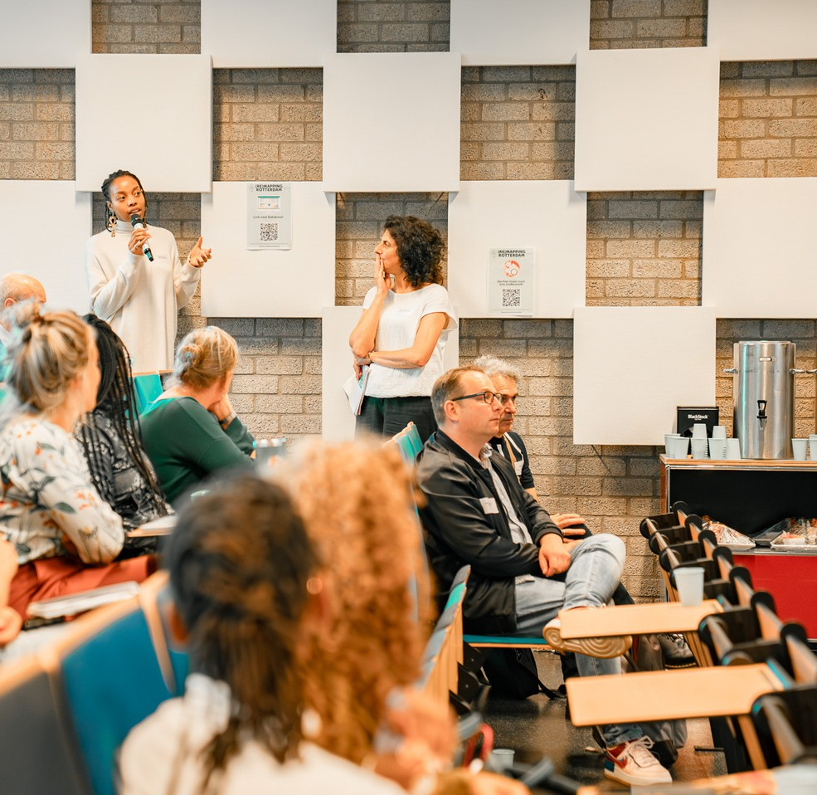

(Re)Mapping Rotterdam Report

Key take aways and tools

By: Dayna-Lee Stewart MA, dr. Maria Schiller & dr. Isabel Awad Cherit

# Introduction

[Re-Mapping Rotterdam](https://www.eur.nl/en/research/research-programme/vcc-projects-page/remapping-rotterdam) is the flagship project of the theme 'Diverse and inclusive Cities" in the Initiative ["Vital Cities and Citizens"](https://www.eur.nl/onderzoek/onderzoeksgroepen-en-initiatieven/erasmus-initiatives/vital-cities-and-citizens) at Erasmus University Rotterdam. VCC aims to enhance the quality of life in urban areas and involves over 30 researchers working on four key themes: Inclusive Cities and Diversity, Resilient Cities and Citizens, Smart Cities and Communities, and Sustainable and Just Cities. The initiative collaborates with various societal stakeholders to conduct practical, impactful research addressing current urban challenges and sharing knowledge with the public through various channels.

Over the past four years our work in the Remapping Rotterdam project was geared to understand the structure of networks among civil society organizations working on diversity and inclusion in Rotterdam, to facilitate meaningful exchanges between and among researchers and civil society in Rotterdam working on diversity and inclusion, and to foster young talents working with us in this project. We gained insights on how power dynamics play out among these organizations, their connections and the overall network. We learned about what organizations would need for a meaningful exchange and collaboration with the university and its researchers during our three networking tours that we organized, visiting organizations and having them present their work to researchers and other civil society organizations. This report summarizes some key take aways from and tools we developed in the project, including a shared database of civil society organizations working on diversity and inclusion in Rotterdam. We hope this may be useful to researchers, civil society organizations, and the municipality and to facilitate collaboration among organizations. The report includes the main insights from our Remapping Rotterdam Forum event, which we hosted on the Erasmus University campus on 21 June 2024.

# Contents

1. Historical vs. Current Structure 3
2. Development of the Shared Database 4
3. Forum & Workshops 5
   1. Mapping Tools 6
   2. Bridging the Academic-Societal Divide: Experiences of Collaboration Between Research and Practice 11
   3. Subsidie Sleutel /Funding 101. 13
4. Outlook and Closing Remarks 14
5. Visual Notes from the Forum - ©Menah Wallen 16

## Historical vs. Current Structure

Historically, Rotterdam's civil society operated under a model known as 'civic corporatism'. In this model, a few larger umbrella organizations acted as intermediaries between the government and smaller entities. These larger organizations received structural subsidies and were expected to support smaller organizations.

This structure provided stability and supposedly would limit competition among civil society actors. It can be visualized as a pyramid, with larger organizations at the top, serving as a bridge between the government and a broad base of smaller organizations.

Our recent analysis sought to determine whether the civic corporatism model still holds and how the network of organizations has evolved. Key findings include:

**Municipality as a Central Actor** - The municipality remains a central player in the network, primarily due to its role as a funding provider. This centrality suggests that municipal support is crucial for the functioning of the network.

**Key Brokers** - Several organizations serve as key brokers within the network. These brokers facilitate connections between smaller

organizations and the municipality.

**Power Dynamics-** Smaller organizations often

face challenges in accessing municipal support directly. They rely on brokers, who sometimes act as gatekeepers, controlling access to resources and information. There is significant competition within the network, which can hinder collaborative efforts. Smaller organizations sometimes feel marginalized and struggle to gain visibility and influence.

•



 

**l&Mlilgl!OI**

To gain deeper insights into these power dynamics, we conducted interviews with representatives from approx. 30 civil society organizations. We asked them about their work in Rotterdam, how they relate to "Diversity" and "Inclusion", which challenges they experience as a non-profit organization, which needs and wishes they have for being able to do their work more effectively etc. Key themes from these interviews included

*"You just see that in different municipalities, they have a number of long-standing partners and they simply get their funding, (._.) and then a lot is actually invested in that knowledge development and exchange, even though it's already there and should actually be directed to the places where you would see a direct difference."\**

*(Fairspace 19:27* ***'1*** *93) [Translated from Dutch]*

discourse and concerns about collaboration and competition linking to criticism of the current model in Rotterdam. While there is considerable collaboration between larger and smaller organizations, competition remains a significant issue. Some larger organizations act as intermediaries, helping smaller one's access funding and attention. However, this intermediary role can also create barriers.

Both smaller organizations and brokers themselves had concerns that the municipality does not always collaborate directly with the most relevant or suitable organizations. This misalignment can lead to inefficiencies and missed opportunities for impactful work.

During the interviews recommendations and calls for improvement were voiced. The need for more equitable collaboration practices was identified, this includes recognizing and addressing the power imbalances and ensuring that smaller organizations have a voice in decision-making processes.

If you would like to read more about our analysis and findings, an academic article on this research can be accessed (open source) [here.](https://www.sciencedirect.com/science/article/pii/S0264275123000318)

Some blogposts on our [networking tours](https://www.linkedin.com/posts/vital-cities-and-citizens_organized-by-thevcc-theme-on-inclusion-and-activity-6878688828262006784-Tc14/?utm_source=linkedin_share&utm_medium=ios_app) and how we sought to foster meaningful exchanges between researchers and civil society actors can be found [here](https://www.eur.nl/en/news/search-meaningful-collaborations-inclusive-rotterdam) and [here.](https://www.eur.nl/en/news/exploring-collaborations-between-academia-and-local-civil-society)

## Development of the Shared Database

A further result of our interviews was that several organizations desire a sort of map or database of all relevant Rotterdam organizations doing similar work. Interviewees indicated they did not know many other organizations unless they directly collaborated with each other, indicating the lack of some sort of overview of organizations and initiatives that would make them visible and accessible to each other.

Through the interviews with nearly 30 representatives from different organizations, we identified 400+ relevant actors using social network analysis. This means we gathered information from all organizations we interviewed about which other organizations, projects, companies etc. they collaborate with. We then used specific in-/exclusion criteria to create a more navigable and useful database for civic society organizations in Rotterdam focused on inclusion, diversity, empowerment and anti-discrimination.

The database we chose to start with was meant to be openly accessible, easy to use, and as low-threshold as possible. We decided to use google maps because many are already familiar with it and it can be integrated into other applications or used as an independent database with the information it already carries.

� Rotterdam D&I Actors - Open Databank * **m** c2,

I.I File Edit View lri�ert Fo11ti&t Data To□ls El-:tensi0/'1$ Help � **Share** • •

• -[,i]+ **BI -6-.!.,** �. IE H· �-.:!:.•l•l·A•

A107 • *Jk* Ronerdams Afbeids etwork �iel.l'l.koff"3rs

Dlt document Is openbaar toegankelJJlc Breng aIleen wlJzlglngen aan voor Deze tekst staat op de websites; organlsatles kunnen de tekst zelr aanpassen of updaten. organisaties waarvQor u toestemming heeft om dez.e to vertogenwoordigen.

Voor algemeene vraagen over dll documen1 alstublleft een emall te sturen aan: [vcc.inclusion@eur.nt](mailto:vcc.inclusion@eur.nt)

2 Organisatie

� VerhalenhuiS;Belvti-dere

4 Stichting Nieuw Thuis Rotterdam fSNTR)

Typ/Soort Stichting Stichting

FocusMlerk/Miss.le

verbindt merisen met elkaar en met de slad door middel van kunst. cultuur en (persoonliJke) verhalen. Dr. erop gerichr dat statushouders cue moeten inburgeren 2ich thuis voeten in Nederl.and en actief meedoen

Wijkpaleis (Huize Middetland)

* **Stlchllng Rotterdamse Sociale Alllantle**

SUchting (Buurtinitiatiei buurtplekk om het le maken. van elkaar te leren, elkaar te ontmoelen en te ondememen.

Stichting zic:h in voor de bestrijding van armoede, schulden en soc:iale uitsluiting en 1S tegen verrijking in Rotte.-darr

1. Netwerk Nieuw Rotterdam Stichting
2. �ip Hop Huis Stichting
3. Stichting Me & Society Stichting

Humanitas: E:11:piertisecentrum Seksualiteit, Sekswerk en

10

Memenhandel Stiehting

WE Organiiation

RADAR/Idem Stichting

Dona Daria Stichling

� SKIN-Rotterdam

een jongerenclub voor jongeren tussen de 16 en 27 jaar, met di\'erse culrurele en religleuze achlergrondE centrum voor jonge creatieven en artistieke gemeenschappen, waarvoor hiphop een verbindende factor i: cre�ren van \'erbindingen, dialogen en meer sociale samenhsng in de maalschappij, waarbij cullurele di...,

biedt dienst- en hulpvertening a.en gemarginetiseerde doelgroepen en .zet zich in voor positiew�rbetering Trainings- en advieswerk op het gebied van: Migratie (lnte,gratie & Ernancipatie) I Diversiteit. inclusie en i1 be\lcrdert gelijk.ebehendeling en streeft naar een samenJeving zonder uitsluiting_

blj te dragen aan *een* inclusieve-samenleving, waarbij theme's zoals zelfbes.chikking, gezondheid, econor .. wil christelijke gemeenschappen samen brengen en ondersteunen. metals doel: stabiele organisaties diE ..

+ � Stichtingen & meer ... grote culturele instellingen ... Gemeente•Regering ...

We added only non-profit oriented, non-political, non-private, non-institutional with their main office and/or projects based in Rotterdam to this list. This allowed us to narrow down to approx. 100 organizations present and active with diversity, inclusion, empowerment or anti-discrimination in the city. [This database](https://docs.google.com/spreadsheets/d/1_y-Xn2VuFEZk-1Z2gMZpSQULh8V6uZXu7Bz7DZMukFE/edit?gid=1066514526#gid=1066514526) functions only as a model and example of how this kind of information can be sorted and archived. Really, we used it as a starting point to explore further possibilities and limitations of (re)mapping.

## Forum & Workshops

On 21 June 2024, we welcomed over 60 guests from civil society organizations working on diversity, inclusion, equality and anti-discrimination, and researchers dedicated to these issues, to join us on campus for an afternoon of learning and exchange. We presented some research findings on relations and power in diversity and inclusion networks in Rotterdam and shared a database of civil society organizations in the city. In addition, we hosted practical workshops about subsidies, tools for mapping own networks and putting oneself 'on the map' and about challenges and how to address them in interactions between academia and civil society. We closed the event with a panel talk sharing perspectives and visions towards new practices of collaborating in Rotterdam.

Throughout the event, visual note taker Menah Wallen colorfully captured participants' main concerns and key interactions in two rich illustrations that can be found on pp. 15-

16. The first one ("Re-Mapping Rotterdam" on p. 15) covers the symposium as a while: It takes viewer/readers from the welcoming of participants and key aims of getting together, through the various workshops, to the fishbowl discussion at the end. The illustration on p. 16 is a more specific visual account of the Map-Lab workshop (see item A below).

### Mapping Tools

The first workshop we offered was about Mapping as both a tool and form of identity & knowledge production. When aiming to create a map, it is important to consider that the act and process of mapping is not neutral and objective. Maps can reinforce inequalities and reflect the views and biases of the person creating the map. In making a map to serve and connect communities it is important that the communities being mapped are given the opportunity to be co-creators in the process. The goal of "(re)mapping" is to work against social inequalities as well as foster diversity and inclusion - in the city of Rotterdam.

Our goal during the project was to explore different ways of making maps, to share and present these to interested organizations and actors and allow them to steer the direction in line with their needs. We intended for the process to be empowering, allowing especially smaller or more peripheral organizations to find new ways to (re)present themselves, showcase the strengths of their organizations and give them tools to take the creation of a map into their own hands.

Why map7 By approaching 're-mapping' as a process rather than a product, it becomes possible to allow for re-orientation and reflection, shifting the focus from creating a product to learning and sharing knowledgel Following the concept of 'Counter mapping', where communities use maps as a tool for empowerment and resistance, we can challenge conventional methods! Things that become possible through re-mapping:

* + Visualize positioning and connections
  + Increase "agency" through self-positioning
  + Reflect on own goals and work
  + Archive and document networks
  + Make new connections and grow your networks

There are various possibilities and options for mapping and visualizing cities, organizations, or communities. Which tool, approach, and/or method you choose depends on your needs and preferences. In the workshop at the forum, we shared a few of many approaches and tools for mapping.

Google Maps is a straightforward and common approach to traditional mapping but also offers a range of possibilities for re-mapping. At a general level, Google Maps facilitates navigation and directions, allowing users to plan routes for driving, walking, biking, or using public transport. Users can search for and discover local businesses, landmarks, and points of interest, with access to user-generated reviews and ratings.

More specifically, Google My Maps enables users to create custom maps with a variety of features. Users can add custom markers with titles, descriptions, and icons, draw lines and shapes to highlight areas and routes, and organize data into different layers for better visualization. Data can be imported from spreadsheets to create detailed custom maps, which can be shared with others for collaborative editing.

Google Maps also supports user-generated content, allowing individuals to contribute reviews, photos, and videos to locations. Users can suggest edits to business information, add missing places, and contribute accessibility information. The platform also offers the ability to save favorite locations, add custom labels, and share real-time location with friends and family. Offline maps can be downloaded for navigation without internet connectivity. Accessibility features help users find routes and locations that are wheelchair accessible, and users can add accessibility information for various places.

In the context of re-mapping, Google Maps can empower users to create maps that provide alternative views. Custom layers can be created to highlight issues such as environmental concerns, cultural landmarks, or social movements. Community maps enable collaboration with local communities to map areas based on local knowledge and priorities. Custom maps can be used for activism and advocacy, promoting causes, tracking events, or documenting issues.

You can access the google map we created [here!](https://www.google.com/maps/d/u/0/viewer?mid=1sSY4rYkRLO9BtPbbB4-agLqmOVJNQS0&ll=51.9200580480906%2C4.488893958390898&z=13)

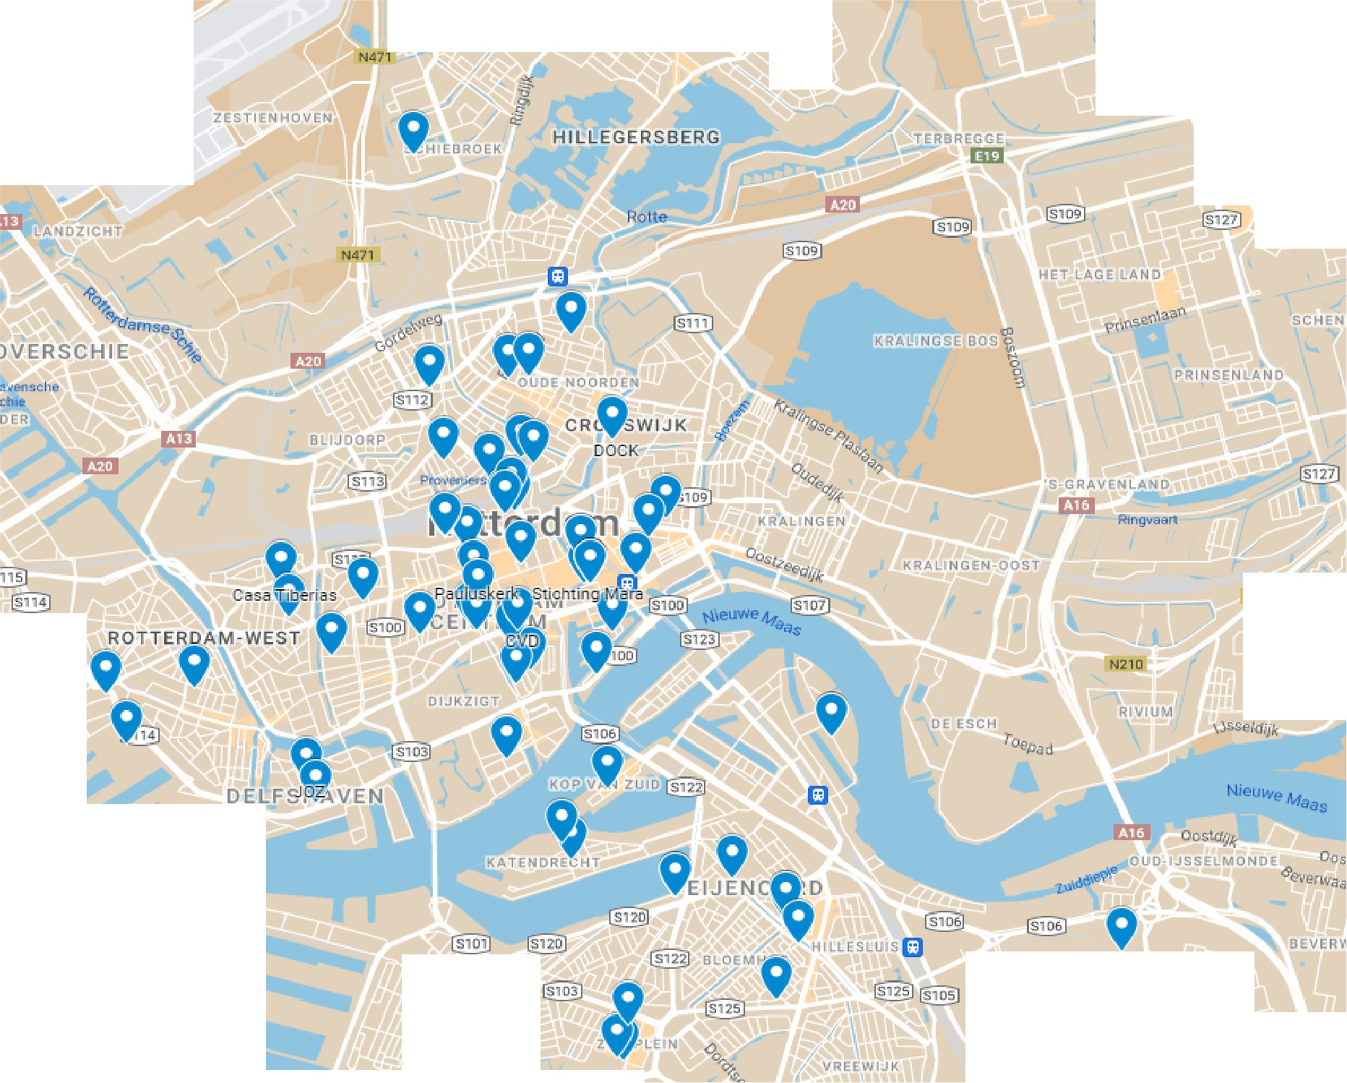

**HI LLEGERSBERG-SCHIEBROEK**

;,;; '¼,'¾

**ftUNS**

**Rotterdam The**

**Hague Airpon**

...,,

**AL.ANDER**

**Cisilia's Youth**

... �

**nm**

**eaurens**

**20�**

'

**OOSTERFU**

t-f.!10

CAPELL

**niseweg**

Hj

l\'ieuwe ""•••

**Dikke Vinger**

**WAAl!HAVEN**

(@I

**CHAR LOIS**

**(I)**

f

%" **�f**.**t**:

**GROENEttHAGEN**

------- ,,••--'

**, �,rltwea.**

Pros:

Cons:

Easy to use.

Information on organizations is often already in Google's database. Allows for layers and filters.

Ability to add or use existing information from Google's database.

Not open source.

Limited to Google's proprietary system

Social Identity Mapping: Social Identity Mapping, as developed within the social sciences, is a tool for mapping diverse and complex identities.

Social identity mapping serves as a valuable tool re-mapping specifically because it enables individuals and communities to visualize and understand the complexities of social identities and their interactions. This approach goes beyond traditional geographic mapping by focusing on the relationships, networks, and social structures that shape experiences and perceptions.

At its core, social identity mapping involves the representation of various social identities, such as race, gender, ethnicity, socioeconomic status, and more. One of the primary applications of social identity mapping is in visualizing power dynamics and social inequalities. By mapping out the various social identities and their intersections, it becomes easier to identify areas of marginalization, differentiation, intersectionality etc. This visualization can be instrumental in raising awareness about systemic issues and fostering discussions about social justice and equity. In the context of mapping organizations, rather than representing individual identities, organizational identities can be mapped instead.

Using social identity mapping for groups, organizations, neighborhoods etc. is a powerful tool for communities to challenge dominant narratives and advocate for change. Communities can create their own maps that reflect their

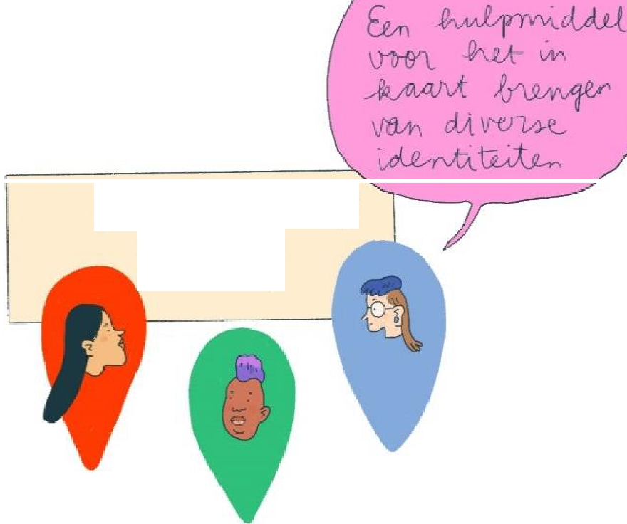

5 *oci61* I Identity

***Mapr;vi_)***

lived experiences, highlighting issues that may be overlooked or misrepresented in mainstream maps. This participatory approach ensures that the voices of marginalized groups are included and that their perspectives are accurately represented.

Social identity mapping also facilitates the exploration of social networks and relationships. By mapping out connections between individuals and groups, it becomes possible to see how social capital is distributed and how networks can be leveraged for collective action. This aspect is particularly useful in community organizing and advocacy work, where understanding

social ties can lead to more effective mobilization efforts. Summarized, social identity mapping can be useful for:

* Understanding (ones' own) social identities
* Recognizing diverse perspectives
* Acknowledging the complexity of (multiple and overlapping) identities
* Stimulating dialogue and reflection
* Discussing the impact of identities on social dynamics
* Developing strategies for inclusivity

The [axis planes](https://drive.google.com/file/d/1edvV0I8eLP3zTDYmbacadpJaEORgQXg-/view?usp=sharing) below are an example of how identity mapping can be approached as an interactive activity for organizations. Prompt: **Position yourself on behalf of your organization, research, or own company on the identity plane (If you do not wish to use one of the axes, you can position yourself on the line of the other axis).**

Rotterdam-wide focus Anti-discrimination

Hulp/ dienstverlenlng

Community engagement/ activism

Diversity Inclusion

Neighbourhood focus

Empowerment

Pros:

Cons:

Helps in understanding and recognizing diverse social identities.

Encourages dialogue and reflection on the impact of identities on social dynamics.

Can be complex to implement and interpret. Isn't intended for geographical mapping

Hashtag coding: Once it is your aim to create categories for organization or better orientation, coding can be a useful method to group text that follow similar rules.

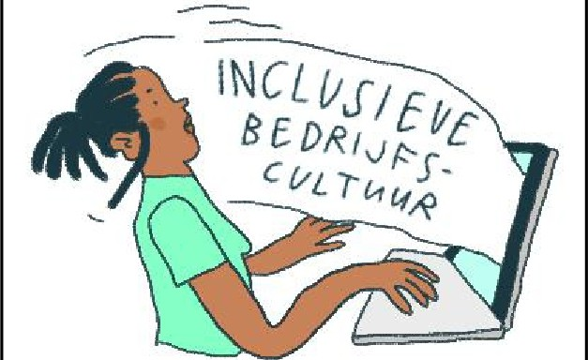

*k�*

*� ��*

*�*

While categorization can be experienced as very limiting, rigid or unflexible, using categories in a way that serves communities can have many advantages such as:

**Clear Classification:** Helps stakeholders understand the primary focus and operational style of each organization

**Targeted Search:** Enables users to quickly find organizations relevant to their interests or needs

**Strategic Partnerships:** Simplifies identifying potential partners or collaborators based on shared goals or methods

**(Resource Allocation:** Assists grant officers and donors in allocating resources to specific types of organizations or goals)

Hashtag coding is an innovative tool offering a unique way to visualize and understand the complex relationships, themes, and dynamics within and across organizations. In this method, hashtags are used as a means to categorize, track, and analyze various aspects of organizational behavior, communication, and structure. Hashtag coding involves assigning specific hashtags to different elements or themes related to an organization.

These hashtags can represent a wide range of categories, such as departments, projects, values, challenges, goals, or any other relevant topics. By doing so, it creates a structured way to organize and analyze data, making it easier to identify patterns and connections.

One of the primary applications of hashtag coding is in communication analysis. By coding internal and external communications (e.g. on social media or a website) with relevant hashtags, organizations can map out the flow of information and identify key themes and trends. This can reveal which topics are most frequently discussed, and how information is shared by the organization. It can also help in identifying bottlenecks or gaps in communication when the data is mapped and shows how the organization is perceived externally.

Pros:

Cons:

Organizes data based on social representation.

Useful for categorization and analysis on platforms like websites, lnstagram, and Twitter.

Requires thorough analysis (time intensive) and regular updates to maintain accuracy.

Can appear inconsistent with an organizations actual intentions

These are only a few of many available tools, methods and approaches that can be used for mapping of connections and networks in a city like Rotterdam. Here are some others we came across while doing our research:

ArcGIS- An open-source alternative to Google Maps.

Terra Stories- Maps indigenous stories, useful for cultural preservation and environmental monitoring.

Ushahidi- Aggregates information for crisis response and management.

How to Choose a Mapping Tool

When choosing a mapping tool for re-mapping, it's crucial to first define the purpose and goals of mapping. Are you highlighting social issues, advocating for change, documenting local knowledge, analyzing organizational structures? Assess the features and functionality offered by different tools. The tool should be user-friendly, allowing team or community members with varying technical expertise to use it effectively. Additionally, ensure it can integrate with your data sources, supports real-time editing, and allows for significant customization to tailor the map to your specific needs.

Consider the cost and accessibility of the tool, ensuring it fits within your budget and meets your hardware or software requirements. Accessibility, including mobile support, is also essential. Evaluate the tool's collaboration and sharing features, such as real-time editing, commenting, and access controls, to facilitate teamwork. Make sure to also think about the sustainability of what you are creating, including how often it will need to be updated and how complex the process is. While there are many tools that can help you create impactful and informative visualizations, it's important that what you choose to do is feasible so that it can be maintained, archived, shared etc.

#### Bridging the Academic-Societal Divide: Experiences of Collaboration Between Research and Practice

How can scientists and civil society collaborate in a meaningful and equitable way? Where are things going wrong, and what can we do about it? Which obstacles require more structural changes, and how can we work towards that7 These questions were addressed during an exchange between researchers and people from civil society in the second workshop of the Remapping Rotterdam Forum.

From many encounters during the (Re)mapping Rotterdam project, we know that there is significant frustration regarding the lack of reciprocity between science and practice.

Sometimes there is a lack of understanding of each other's needs, knowledge is often 'taken' without giving anything in return, and the university appears as an authoritative institution that is often not very accessible. It can also be challenging to gain access to civil society and, once gained, to build a long-term trust relationship. The trend of 'societal impact' at universities does not always help in building meaningful relationships, and there is little reflection on negative impacts.

At the same time, many people in both science and practice are eager to build meaningful relationships and collaborations, driven by their commitment to make the city more inclusive and equitable. Therefore, we sought, together and in dialogue, to identify challenges and possible opportunities for collaborations, and to build reciprocity and trust in our relationships. We have summarized these as a sort of 'checklist' of what can go wrong, but also how to approach it better.

|  |  |
| --- | --- |
| CHALLENGENS/WORST PRACTICES | OPPORTUNITIES/BEST PRACTICES |
| Universities **overburdening** civil society organizations: One person mentioned how sometimes three faculties approach them within a few weeks: "Every week someone comes to vulnerable neighborhoods." | Request for more **streamlining/coordination**  within the university to prevent overburdening  **Positioning oneself differently as a civil society organization:** Create a course together with lecturers, provide training to lecturers as a civil society organization, co- write research proposals  **Introduce challenges in education:** Present these to students, who then attempt to formulate possible solutions |
| **Research Bias:** When reality is framed by researchers (e.g., a specific group as 'vulnerable girls') in a way that does not correspond with the actual reality  **Target group approach-** Stigmatized, blame the problem on the target group itself | Researchers reflecting on their own **Positionality:** Often, white researchers come to Black communities, heterosexual researchers to LGBTO+ groups, etc.  View **Societal Problems** as the starting point instead of Target Groups: |
| **Lack of Reciprocity in Research:** Requesting the studied group to participate in research for free. | True Collaborative Union: Ideally, a **researcher becomes genuine part of an organization** and understands from within what is helpful or not  **It takes time for** researchers to be present in a neighborhood and to be seen as partners rather than outsiders.  **Matching Research Questions with Needs from Civil Society Organizations:** Aligning research questions with the needs of civil society organizations is crucial for meaningful collaboration.  **Increased Co-Creation** in Research: Involve the group being researched in shaping and |

|  |  |
| --- | --- |
|  | conducting the research. Train participants as researchers and have them conduct interviews and other research tasks.  Creating **Added Value** for the Target Group through Research: Reflect on the participants' question, "What can I do with this research?" |
| Grant applications often require a 'societal partner' but do not provide the space to also apply for **funds for the societal stakeholder.** | **Lobbying** at research institutions to make funds available for smaller societal partners as well.  **Lobbying** at universities to develop 'funding advice' for collaborations with civil society as well. |
| Ethics procedures often require filling out long questionnaires-this takes too much time from participants and often it is **not clear how it is in their interest.** | **Compensation** for research participants  Lobbying privacy officers to simplify ethics procedures as much as possible, to respect the time of research participants |

This checklist alone won't solve these frustrations and identified problems - but it does provide very concrete prompts to think about what should be done. We hope it can contribute to developing concrete activities or improving existing practices! Continuing this dialogue could be an important first step in this process.

### Subsidie Sleutel /Funding 101

The third workshop we organized at our forum was all about municipal funding for civic society organizations in Rotterdam. Throughout the re-mapping project, we observed that relations among civic organizations and with the municipality are strongly influenced by financial considerations, most notably the distribution of municipal subsidies.

Especially smaller organizations in Rotterdam struggle to access sufficient resources to do their work and to secure some continuity. Working together with other organizations - including larger so-called brokers-can be helpful. However, it is not always clear whether and how municipal financial schemes can facilitate collaborations.

As part of the policy plan "Living together in one city" (Sameleven in een stad), launched in autumn 2023, the municipality of Rotterdam has a revised funding scheme to support organizations working on its diversity-related priorities: discrimination and security, equal opportunities, and connecting. Every year, organizations can apply for a maximum of

75.000 euros for new projects that fit within one of the policy's five specific goals.

How does this new scheme affect smaller organizations working on diversity and inclusion in Rotterdam? How can they successfully apply for funds associated to the "Living together in one city" policy7 Initial answers to these questions can be found in the

**attached slides.** In the Re-Mapping Forum of June 21, 2024, Denise Zending, from Rotterdam's municipality's "Living together in one city" team shared these slides during a special workshop about the new funding scheme. Her presentation triggered a productive conversation with 12 representatives from relatively small social organizations in the city (or planning to start one) who joined the workshop together with three EUR academics, a representative from the municipality of Mannheim, and from that city's "One World Forum" alliance.

Key concerns among participants in the workshop had to do with the regular change in funding rules and the fact that subsidies go to (new) projects or activities, but do not support the regular tasks of organizations and their continuity. Moreover, while representatives from organizations shared their contacts to stay in touch and try to work together, there was some concern that the subsidy scheme is not (yet) sufficiently specific on the available financial support for collaborations.

**Final fishbowl discussion**

For the final fishbowl discussion we invited four people to the podium to kick *off* a discussion, with others spontaneously joining the podium during the discussions (where one empty seat was provided) at any point. The various organizations, whose representatives took a seat at the podium included the municipality of Rotterdam's anti­ racism and discrimination office, foundations N8W8, Het Rode Lint, Nieuwe Thuis Rotterdam, and RoSA.

The dialogue among the panelists and with members of the audience -including the representatives from Mannheim-allowed for a valuable exchange of ideas and experiences across the two cities. Rotterdam-based panelists were curious about how the Mannheim model is funded, how organizations are compensated for their participation, and how collaborations between the municipality and civic actors sustained. They heard about the Mannheim mayor's strong commitment with the project and the importance of the federal funds allocated to it. Overall, there was broad agreement that the example of Mannheim was inspiring, even if some aspects already had been tried out and existed in Rotterdam too (e.g., the intercultural calendar).

Representatives of Rotterdam organizations underscored the specific challenges they face, first and foremost due to the rather frequent change in political orientation of the city council, which implies unstable visions and ideas about what needs to be done, how and by whom. For some, this explains why some important goals and visions have not been achieved after many years of struggle and work. Also, some actors recognized that 'we are good in Rotterdam in creating our topic islands', with organizations working on their specific issues, sometimes at the expense of intersectionality and complexity.

Changing trends in who or what gets attention and benefits and who/what does not also threat organizations' sustainability.

Funding and the rules linked to the provision of subsidies were considered as the crucial 'key' for shaping the relations between the municipality and civil society organizations.

This already manifests in the decision of whether something should be framed as a project or whether it requires the creation of a foundation (i.e. stichting), with the latter being a prerequisite for funding. Especially challenging is this for marginalized groups or individuals who often do not have the time, energy or resources to participate in established organizations, whilst they may need support for their initiatives the most.

Faced with these challenges, a podium participant argued that full independence from municipal subsidies would be ideal for organizations. This led to a discussion about their increasing reliance on charities and foundations for funding. The question was posed about the challenges and struggles associated to this, not the least in terms of public accountability. Other panelists suggested that municipal funding must remain an important ingredient in supporting and allowing certain activities to happen, but that it needs a more long-term strategy or a sort of convenant also with smaller organizations to ensure they can engage in long(er) term planning.

Overall, the fishbowl discussion underscored real possibilities and value for meta-level, collective reflections on 'how things are done' and 'how things could be improved' to strengthen collaborations and promote inclusivity in the city. Local actors are willing to engage in (self) reflection, despite some actors' frustration about conversations returning to the same topics again and again, without much progress.

As organizers, we thought the discussion confirmed the need for the further institutionalization of spaces of thinking together about how things are done and how they could be done better in terms of funding and collaboration on diversity and inclusion in the city of Rotterdam. As one person said: perhaps we should get together once per year to reflect on how things are going and where one wants to be going.

## Outlook and Closing Remarks

In this report we offered main take aways as well as shared insights about some of the tools we have developed in the Remapping Rotterdam project. Whilst the project of Remapping Rotterdam concludes by the end of 2024, we learned through our work that collaborations do not solely rely on project runtimes - they become 'alive' through personal connections and networks, by finding each other and putting each other 'on the map'. In this spirit, our work will continue, and we are committed to keep building meaningful connections with civil society actors in the city with the goal of working towards a more just and inclusive Rotterdam. We hope that some of the tools may be used and be useful. We are open to explore together any further uses of the database and mapping tools, support and answer questions as much as is possible, and build collaborations for working together in mutually beneficial and meaningful ways in the future.

We would love to hear from you. Please don't hesitate to reach out to theme leads cir. Maria Schiller and cir. Isabel Awad with any questions, suggestions, ideas or initiatives. They can be best reached here:

[Schiller@essb.eur.nl](mailto:Schiller@essb.eur.nl) [Awad@eshcc.eur.nl](mailto:Awad@eshcc.eur.nl)

Visual Notes from the Forum - ©Menah Wallen

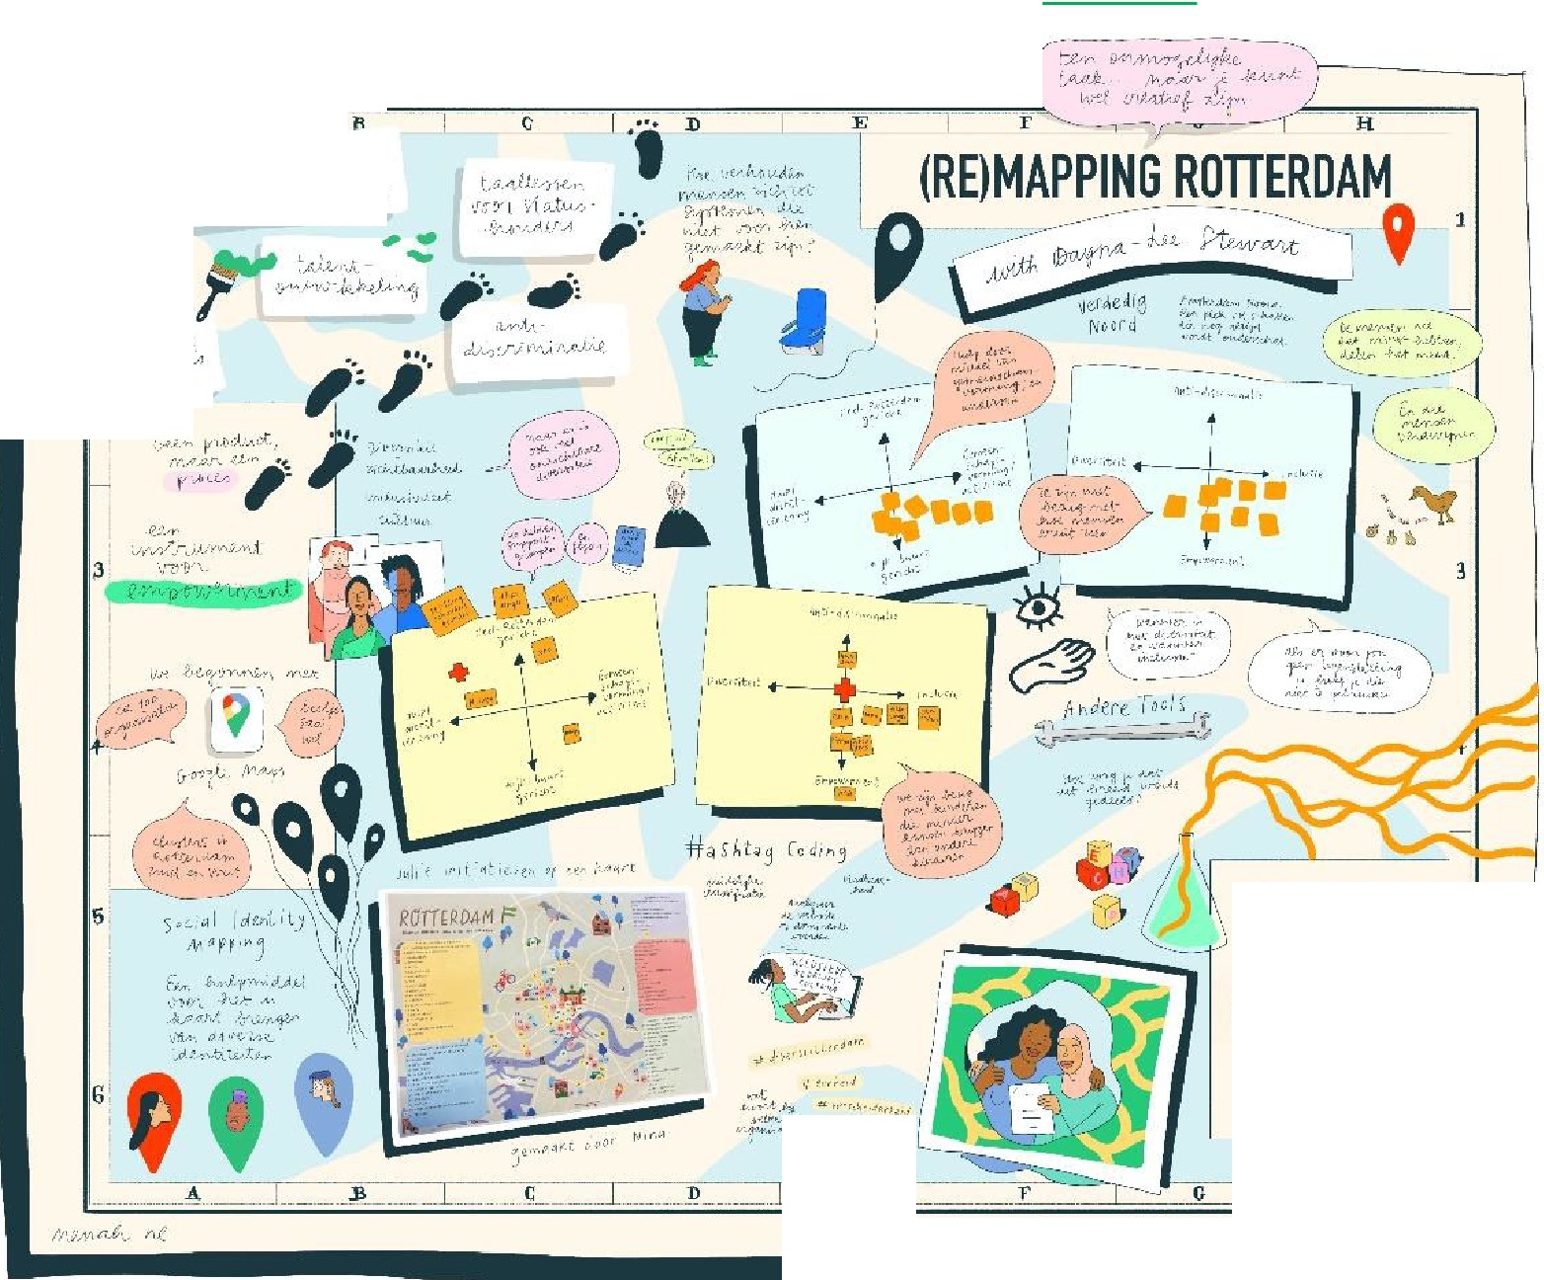

\

A

1Js. *•..J�I,f",.* ·�,-��""!.

(?',',1{.t1v',:•icV"'•'"'',-,tJ.,.�_,jJ,ts

2

-

**Maplab**

ldentiteit & Positionering in kaart brengen

r

"

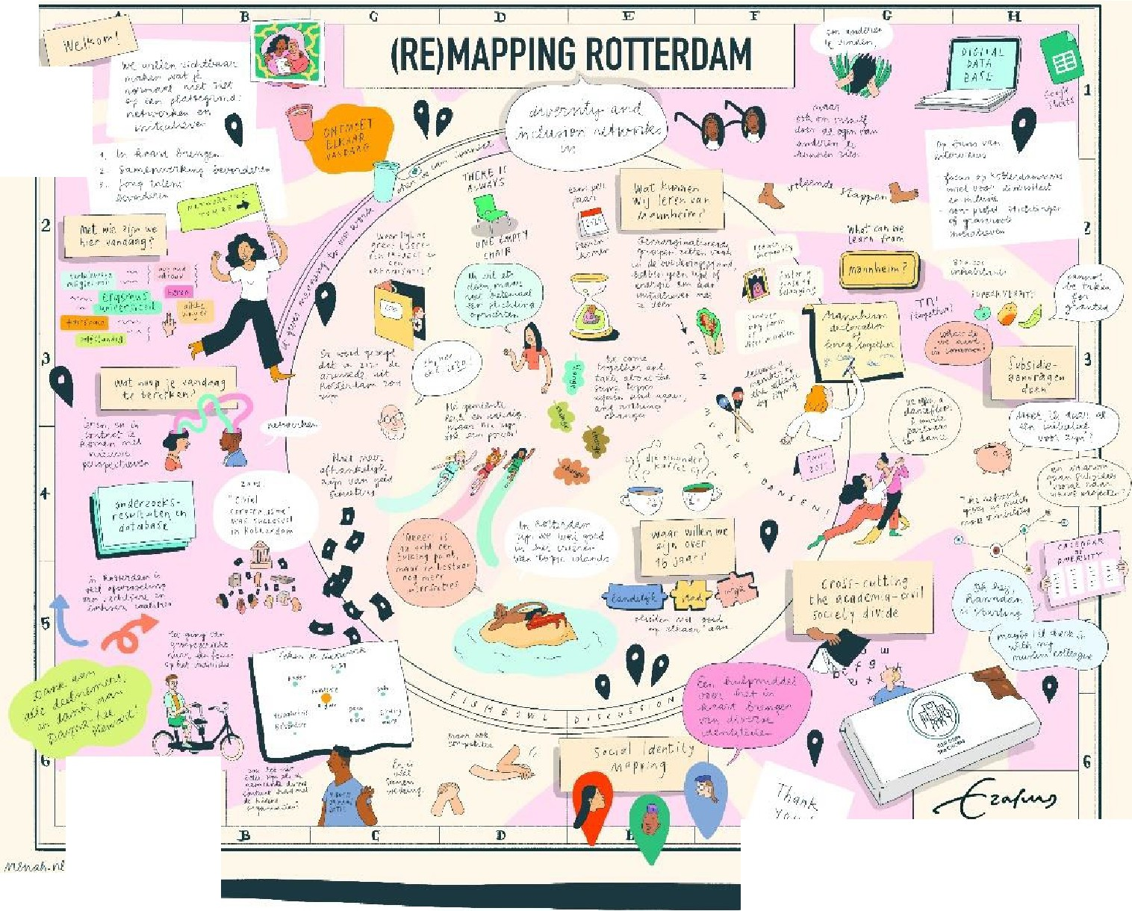

'

21 JUNE 2024

A

G

It