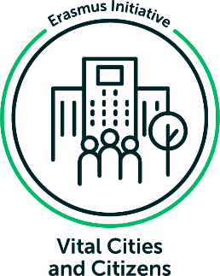
A Just and Effective Wind Energy Transition: Six Insights from Denmark and the Netherlands

A blog by DRIFTers Audrey Wientjes & Lina le Pelley
The energy transition provides us with a unique opportunity to move towards a fair and participatory energy system - but getting there is easier said than done. In this blog, DRIFTers Audrey Wientjes and Lina Le Pelley share their insights from the EU Horizon Project JustWind4All. This project explores the challenges of the wind energy transition through regional case studies. Audrey and Lina highlight six “lessons learned” for participatory, inclusive, and just wind energy development, drawing from the case studies of Denmark and the Netherlands.

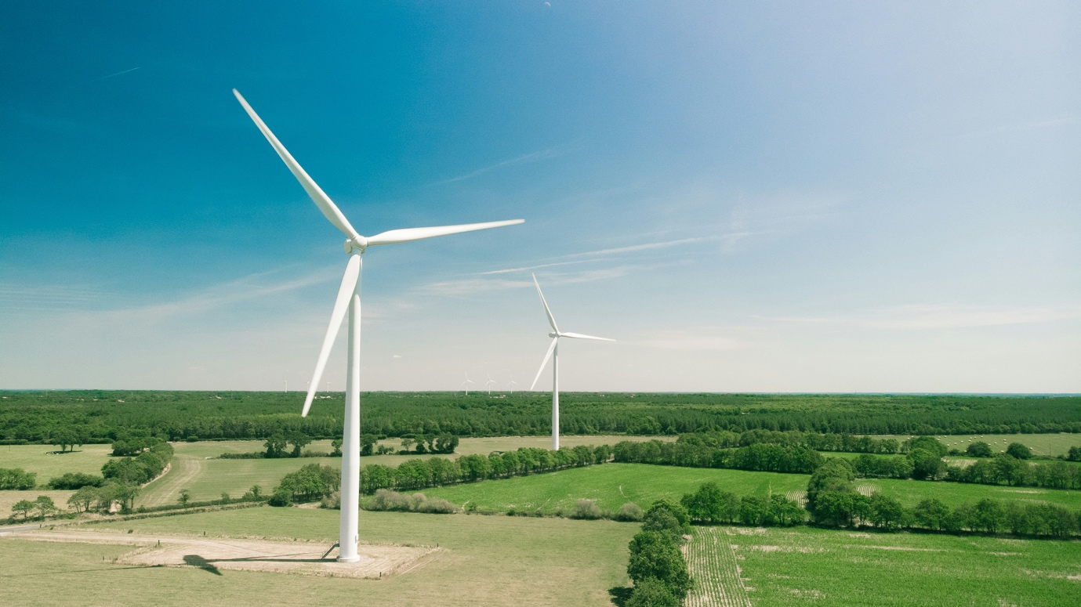
Source: Photo by Thomas Reaubourg on Unsplash
Current European Union (EU) targets require a rapid scale-up in renewable and wind energy technology in the coming years. However, a history of contestation and protest surrounding wind energy has brought questions of participation and justice to the forefront of this transition. The EU Horizon project JustWind4All, with its 13 consortium partners, addresses these questions in its investigation of the wind energy landscape in Europe through seven empirical case studies. Employing a mixed method approach including document reviews, media analysis, and interviews, these case studies offer key recommendations to foster energy citizenship through effective and just energy governance.
We highlight the findings of two regional case studies - the Netherlands and Denmark - delving into six “lessons learned” for participatory, inclusive, and just wind energy development in these regions. We also reflect on the broader context, asking how we can conceptualise the green transition, and raise reflexive open questions applicable to any region.

Case Study 1: North Holland, the Netherlands
In this case study, we examined the development of wind energy governance in North Holland - a province home to both the capital Amsterdam and a large swath of rural area - investigating implications for a just and participatory energy transition. The Netherlands, with its flat landscape and large coastline, has long established its place as a wind energy frontrunner, with ambitious targets cut out for the coming decades. However, limited space and ongoing protests against further onshore wind development have led to a radical new approach in onshore wind energy planning: the Renewable Energy Strategies (RES). Initiated in 2019 with the Dutch Climate Agreement, the RES divides the country into 30 regions for bottom-up renewable energy development, with each region allowed to set its own targets and guiding principles with a focus on local participation. North Holland's RES divided the province into two regions and emphasised stakeholder participation and community ownership in its approach. However, onshore wind remains a minor part of future plans, with solar energy taking precedence (Stuurgroep Regionale Energiestrategie, 2021). While openness to renewable energy increased following the onset of the energy crisis in 2022, ongoing protests against onshore wind, both in rural and urban areas, have centralised around a clear message: put the turbines at sea.
As a result, the Dutch government has set its sights on rapid, technologically focused development offshore, with plans to increase capacity five-fold by 2030, compared to 2023 (New Offshore Wind Energy Roadmap, 2022). Advancements in technology allowing for economically viable installations further from shore and collaboration between key stakeholders has facilitated a relatively smooth and swift expansion of plans and realised capacity in recent years. However, there is still limited knowledge of the cumulative biological effects of offshore wind development on the North Sea, and scientists have warned that a massive scale-up of turbines may trigger important ecological tipping points. This has highlighted a delicate balance that needs to be tackled: reducing carbon emissions through the energy transition, while keeping ecosystems intact. In addition, while in recent years onshore wind has become increasingly citizen-led and citizen-owned, offshore wind is mostly developed by corporate stakeholders. All in all, this indicates that further steps are needed to ensure a just and equitable wind energy transition for all, particularly with regards to offshore wind.
Case Study 2: MidtVest, Denmark
In this regional case study, we investigated the dynamics of repowering wind turbines in the MidtVest business region of Denmark. As one of the earliest pioneers of wind energy in the 1990s, Denmark continues to set ambitious targets today, and has committed to being 100% powered by renewable energy by 2035 (currently, renewables constitute 50% of energy production). Despite these goals, wind energy has stalled in recent years, with local scepticism for existing and proposed wind parks growing, and contestation increasing. This may be partially due to shifts in ownership models - Danish wind energy development began with local wind cooperatives: a bottom-up, participatory ownership model, that has since been replaced with the dominance of larger, often international investors due to market liberalisation and changes in tendering regulations (Kirkegaard et al., 2023). Compensation schemes, local participation requirements, and local ownership opportunities have been implemented over the years to recentre the local community in wind energy development and increase public acceptance. Nevertheless, some wind projects remain unsuccessful, and many actors increasingly see the future of Danish wind energy in offshore wind, which comes with its own tensions and environmental risks.
As one of the early players in wind energy, Denmark is currently facing the challenge of wind turbines reaching the end of their lifespan. “Repowering” refers to replacing a part or the entirety of a wind turbine and installing a new one in its place; typically leading to an increase in productivity/capacity (Gorroño-Albizu, 2018). Especially in Business Region MidtVest (the focus of this case study) there is still a lot of potential for onshore repowering. The large number of onshore wind turbines in the region means that repowering initiatives have a lot of potential for significantly increasing energy production in the area and helping Denmark reach its climate and renewable energy targets. Yet, repowering has declined in popularity and is largely absent from the planning for future wind energy production in the area. In a period of limited onshore space and increasing resistance, repowering initiatives in combination with offshore wind could significantly contribute to the future of Danish wind energy by reducing the total number of wind turbines on land while increasing energy production. When considering this path forward, more work needs to be done to ensure distributional and procedural justice in the development process.
For more detailed information on the case study findings, see the JustWind4All case study reports.

Six Lessons Learned
Reflecting on the findings of the case studies, we present six lessons learned from the Danish and Dutch cases:
- Local value creation is at the heart of effective wind energy development. The data from North Holland and MidtVest both indicate that wind projects tend to be more popular with residents in the area when there is a strong local connection, i.e., participation and ownership on a local level. In North Holland, local communities were able to independently define regions for renewable energy development in their region as part of the Regional Energy Strategies (RES). This stimulated and increased citizen engagement with wind energy.
In MidtVest, the Sdr. Bork repowering project was popular with local residents in the area, who were able to invest in the wind park by purchasing shares, an option which wind developers must provide for citizens under the Buyer’s Rights Scheme. Sdr. Bork Vind K/S, the company behind the repowering project, was made up of local landowners and the 21 owners of the original wind turbines. Through these local actors, residents were able to "see themselves" in the project. In the development process, these "local forces" collaborated well and cultivated positive working relationships through their strong ties to the surrounding community. Here, the developers’ interpersonal, locally-rooted approach and continuous consultation ensured that residents felt heard and respected.
- Justice doesn’t have to be the enemy of acceleration. Justice is often painted as a trade-off for accelerating the energy transition (Van Bommel & Höffken, 2023). However, failure to consider local impacts and voices often results in tensions and contestations, which are counterproductive to change, either delaying projects or damaging local trust further down the line. Through our case study work in North Holland, we saw that pushback from the north of the province predominantly resulted from a previous project which failed to adequately address participation and a fair distribution of benefits and burdens in the local area. Placing these issues at the forefront through the RES approach has necessitated focusing on plans agreed by all while putting implementation on the back burner. While the jury is still out on the speed at which these plans are implemented in the coming years, it is important to be wary of viewing justice and acceleration as a binary.
Research on the Danish case in MidtVest demonstrates that acceleration and justice can go hand in hand, but also that foregoing a just process in favour of acceleration can be counterproductive. For example, the Midtjyske Motorvej wind turbines were a highly unpopular project, built in time to receive a national subsidy before the funding scheme ended. Residents’ complaints about the large installed capacity of the new turbines were ignored in favour of acceleration: however, the turbines ended up remaining inoperable, as there was no transformer station or grid connection in place with the capacity to capture the surplus energy produced by the turbines. This case demonstrates how acceleration without justice can paradoxically lead to deceleration further down the line.
- Don’t forget lessons learned when implementing emerging energy technologies. With emerging technologies, we often see an initial period of rapid expansion, followed by increasing resistance as local trust is broken or spatial planning becomes constrained. In the Dutch case, onshore wind is emblematic of this trend. With offshore wind now experiencing its period of rapid expansion, it is important that we apply lessons learned from onshore wind energy to wind at sea. We need to consider local impacts by conceptualising the sea as a populated landscape with more-than-human residents (such as marine life and ecosystems) and invest in ways to make their interests part of the decision-making process.
In Denmark, it has also become common to envision the future of wind energy as solely possible in offshore developments. However, these are generally expensive projects that often involve foreign investors and larger corporations: meanwhile, a perceived lack of local ownership and decision-making power is already a major factor behind the contestation of onshore wind developments in MidtVest. This suggests a need to explore pathways for onshore community engagement through building capacities in community energy organisations and local governments, and considering how justice and participation can still be included in offshore wind energy.
- Actionable participation guidelines are necessary for the effective implementation of a just and participatory transition. While the RES guidelines in North Holland set 50% local ownership in projects as a clear goal, there is a need for legal solidification and enforcement in order to translate this to reality, as well as agreed definitions of what is meant by participation and ownership.
Regarding onshore wind in MidtVest, wind project developers (alongside municipalities) are required by law to host at least two interactive information sessions aimed at citizens during the development process. Citizens then also have time over two “consultation” or “hearing periods” of eight weeks to provide feedback on the project and the municipality’s planning documents. Strategies like this take steps to define what participation and ownership in wind energy projects could and should look like, transforming them from abstract concepts into tangible practices.
- When trying out new governance structures, create reflexive governance structures that allow for reflection, learning, and action. In North Holland, while participation and justice have been placed as a guiding principle for onshore renewable energy development, there are limited avenues instituted for reflection upon RES progression as projects are implemented. While progress is broadly monitored, there is a need for local evaluation of whether justice (procedural, distributive, recognition) and participation have been successfully included, and sessions for improving upon the current strategy.
Reflexive governance could also be valuable for reevaluating approaches to renewable energy development, on both a national and local level, in contexts like Denmark. For example, despite official legislation stipulating citizen involvement in wind projects, many residents in MidtVest feel that their concerns regarding onshore wind are overlooked and that wind projects do not benefit their communities. This suggests a shortcoming that reflexive governance practices could address.
- Keep sight of the overall goal: a habitable planet for all species, balancing both keeping ecosystems intact and renewable energy development. Currently, the energy transition in both the Netherlands and Denmark is focused on the “gigawatts” and reaching certain quantified targets, rather than on how we want our relationship with energy and our local ecosystem to look like. By envisioning future relationships rather than installed capacity, we avoid narrowing our attention to a single technology, such as (offshore) wind energy development. Instead, provide space and resources for innovators to experiment with a diversity of transition pathways. This includes seeking potential synergies, such as combining the development of renewables with energy sufficiency (i.e. shared mobility, energy citizenship, post-capitalism, and de-growth pathways), and investigating alternative business and organisational models.
Reflexive Questions to Consider
As we wrap up, let's fuel some dialogue and introspection. Consider: how do these six lessons apply to your country or regional context? What elements do you think are missing from current approaches to the energy transition? What do you think a successful energy transition should look like? And finally, where do you see your own role in this process – how would you want to be involved?

Reference list
Gorroño Albizu, L., Pagani, D., & Brink, T. (2018). Denmark.
Kirkegaard, J. K., Rudolph, D. P., Nyborg, S., Solman, H., Gill, E., Cronin, T., & Hallisey, M. (2023). Tackling grand challenges in wind energy through a socio-technical perspective. In Nature Energy. Nature Research. https://doi.org/10.1038/s41560-023-01266-z
New Offshore Wind Energy Roadmap. (2022, December). RVO. https://english.rvo.nl/information/offshore-wind-energy/new-offshore-wind-energy-roadmap
Stuurgroep Regionale Energiestrategie. (2021). RES 1.0 Noord-Holland Noord (p. 156). Noord-Holandse Energie Regio. https://energieregionhn.nl/res
Van Bommel, N., & Höffken, J. I. (2023). The urgency of climate action and the aim for justice in energy transitions – dynamics and complexity. Environmental Innovation and Societal Transitions, 48, 100763. https://doi.org/10.1016/j.eist.2023.100763

About the authors
Audrey Wientjes is a research assistant at Drift specialising in just wind energy transitions. In addition, she is pursuing her master’s in Industrial Ecology at TU Delft and Leiden University, specialising in a systemic approach to sustainability issues, integrating engineering, environmental and social science perspectives.
Lina Le Pelley is an intern at Drift in the JustWind4All research project. She recently completed her bachelor’s in Cultural Anthropology and Development Sociology at Leiden University, having written her thesis related to themes of sustainability: specifically, the role of colonialism and racialization in African nature conservation.

