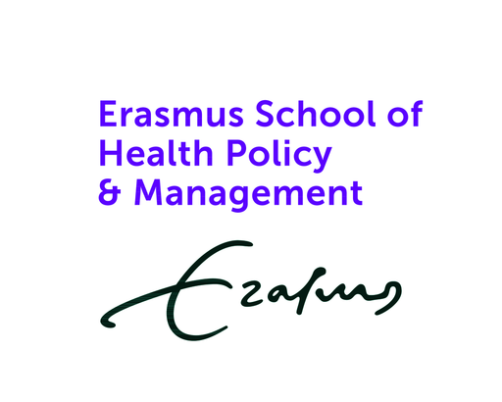

Information about the Erasmus University Rotterdam course
Analysing and Changing Unhealthy Behaviour (ACUB) is an Erasmus University Rotterdam minor course (10 weeks) coordinated by Erasmus School of Health Policy & Management (dr. Stefan Lipman), developed as part of Erasmus Initiative: Smarter Choices for Better Health. The course attracts students with a variety of backgrounds, for example: psychology, business administration, criminology, and health sciences. These students are taught a set of basic principles from various strands of economics, with a focus on behaviour change. In the course, we first explore what makes behaviour ‘rational’, as well as immediately discussing that many of us can be considered irrational. For example, we make plans to quit smoking, exercise more, eat healthier, but fail to follow through with them. In the course, we discuss behavioural insights that help us understand why this happens, but more importantly, what kind of interventions we could use to change unhealthy behaviour. Examples of types of interventions discussed are: information campaigns, taxation, financial incentives, and behavioural interventions such as nudges and boosts. Students in the course develop an intervention, in which they analyse a health-related behaviour that needs changing and consider how to change it using the interventions discussed.

ACUB aims to equip students with the latest psychological and economic insight into behaviour change, as well as let students use their creative energies to apply these insights. Field partners have the opportunity to benefit from our students’ creativity, potentially yielding multiple innovative evidence-based solutions to the challenges they base their case text on. Furthermore, being a field partner involves the opportunity to establish a lasting collaboration with Erasmus University Rotterdam staff as well as connecting to our motivated students.

Important dates to keep track of are:
The week of September 15th – Online sessions with field partners and student groups to exchange first ideas
Between 6 and 10 October – Students visit the field partner at a location of their choice (potential meetings with target group and/or additional exchange of ideas).
Tuesday October 28th: 13:00-17:00 – In person symposium on Erasmus University Campus with final presentations

Introduction to your organisation
Please give a short introduction to your organization (i.e. its’ core business and mission). (e.g. 200 words).
Introduction to the behavioural challenge
Please provide a short description of the behavioural challenge your organization is facing or tasked with addressing. Please consider describing shortly: what is the problem, why is it a problem and for who? (e.g. 350 words per case).
Main questions
Please give an example of a main question you would like the student team to answer with their designed intervention.

Organisational context and existing resources/constraints
As part of the course Analysing and Changing Unhealthy Behavour, students will come up with a potential intervention to use to tackle behavioural challenge you outlined. In order, for such an intervention to be potentially applicable in your organization, please describe the context in which it would be used. For example, consider describing:
- Who would be responsible for implementing the intervention?
- How much resources (personal/financial) are available to implement the intervention?
- How long will you be able to study the behavioural challenge?
- To whom should results be communicated and when are they expected?
(e.g. 350 words)

Once you have completed this form, you can send it to lipman@eshpm.eur.nl

